NRC INSPECTION MANUAL DANU/UARP
INSPECTION MANUAL CHAPTER 2571

DISPOSITIONING ADVANCED POWER REACTOR
CONSTRUCTION NONCOMPLIANCES
Effective Date: 02/05/2026

TABLE OF Contents
2571-01 PURPOSE 1
2571-02 OBJECTIVES 1
2571-03 APPLICABILITY 1
2571-04 DEFINITIONS 2
2571-05 RESPONSIBILITIES AND AUTHORITIES 4
2571-06 REQUIREMENTS 5
2571-07 GUIDANCE 5
07.01 Application of the NRC Enforcement Policy and Enforcement Manual to ARCOP Noncompliances 5
07.02 Self-identified Construction Noncompliances (SCNs) 6
07.03 Findings Material to the Acceptance Criteria of ITAAC 7
07.04 Very Low Safety Significance Issue Resolution (VLSSIR) 7
07.05 Technical Assistance Requests (TARs) 8
07.06 Initial Screening of ARCOP Noncompliances 9
Figure 1: Initial Screening of Noncompliances 11
07.07 Dispositioning Licensee Findings 12
Figure 2: Dispositioning Licensee Findings 13
Figure 2a: Dispositioning Licensee Findings (continued) 13
07.08 Dispositioning Non-Licensee Findings 14
Figure 3: Dispositioning Non-Licensee Findings 14
07.09 Dispositioning Noncompliances Involving Potential Willfulness 14
07.10 Dispositioning Non-Willful TE Noncompliances 14
Figure 4: Dispositioning Non-Willful TE Violations 17
07.11 Enforcement Review Panel Procedures 17
2571-08 REFERENCES 18
Attachment 1: Abbreviations Att1-1
Attachment 2: Determining if an ARCOP Noncompliance is Minor Att2-1
Figure 2.1: Determining if an ARCOP Noncompliance is Minor Att2-2
Minor ARCOP Noncompliance Examples Att2-5
Attachment 3: ARCOP Finding Significance Determination Att3-1
Table 3.1: SSC Significance Determination Att3-2
Attachment 4: Process for Appealing an NRC ARCOP SDP Determination Att4-1
Attachment 5: Alternate Significance Determination Att5-1
Table 5.1: Decision-Making Attributes for NRC Management Review Att5-2
Attachment 6: Revision History for IMC 2571 Att6-1

2571-01 PURPOSE
This Inspection Manual Chapter (IMC) provides instructions and guidance for dispositioning advanced power reactor (AR) construction noncompliances, the responsibilities and authorities of applicable NRC staff, requirements for use of the ARCOP significance determination process (SDP), requirements to convene an Enforcement Review Panel, and the process to appeal the significance of findings.

2571-02 OBJECTIVES
02.01 Provide instructions and guidance for dispositioning advanced power reactor construction noncompliances.
02.02 Specify applicable NRC staff responsibilities and authorities to ensure ARCOP noncompliances are objectively supported and properly dispositioned.
02.03 Provide details specific to the ARCOP for implementing the NRC Enforcement Policy and Enforcement Manual.
02.04 Provide ARCOP noncompliance initial screening criteria.
02.05 Provide ARCOP full screening criteria to assign appropriate safety or security significance characterization to findings through the ARCOP SDP, and to determine the appropriate enforcement or administrative action for the findings (e.g., notice of violation (NOV), non-cited violation (NCV), notice of nonconformance (NON), Notice of Deviation (NOD), etc.).

2571-03 APPLICABILITY
The NRC developed the advanced reactor construction oversight program (ARCOP) to be implemented at all ARs under construction, including commercial SMRs and microreactors incorporating both LWR and non-LWR technologies. Given the Commission expectation that ARs will provide enhanced margins of safety and/or use simplified, inherent, passive, or other innovative means to accomplish their safety and security functions, ARCOP oversight also applies to construction of large LWRs with enhanced safety features, such as the AP1000.
This IMC applies to noncompliances identified during ARCOP inspections conducted per IMC 2573, “Inspection of the Advanced Power Reactor Quality of Construction Strategic Performance Area,” IMC 2574, “Inspection of the “Operational Readiness” Strategic Performance Area of the Advanced Reactor Construction Oversight Program (ARCOP),” IMC 2203 - “Security Inspection Program for Advanced Power Reactor Construction,” and IMC 2501, “Inspection Activities Following Acceptance of a Docketed Application for a Permit, License, or NRC Authorization.” This IMC shall also apply to supplemental inspections as directed by IMC 2572, “Assessment of Advanced Reactor Construction Projects.” This IMC shall be implemented when the NRC accepts and dockets an application for a combined license (COL), construction permit (CP), manufacturing license (ML), or a limited work authorization (LWA) that is associated with an advanced power reactor. This IMC is no longer applicable when an advanced power reactor transitions to the startup or operations phase, as indicated by a 10 CFR 52.103(g) finding that all ITAAC are complete (for COL holders) or when the NRC issues the facility an operating license (OL).

2571-04 DEFINITIONS
Applicable ARCOP definitions are in Inspection Manual Chapter 2570, “Advanced Reactor Construction Oversight Program General Guidance and Basis Document.” For readers’ convenience, some relevant definitions are also listed below.
- Administrative Actions. Actions such as confirmatory action letters, notices of deviation, and notices of nonconformance that are issued to supplement the NRC enforcement program. These administrative actions are explained in the Enforcement Manual. The NRC expects licensees and other persons subject to the Commission’s jurisdiction to adhere to any obligations and commitments resulting from administrative actions and will consider issuing additional Orders, as needed, to ensure compliance.
- Apparent Violations (AVs). Issues that do not appear to meet NRC requirements and for which the NRC staff has not made a final enforcement determination.
- ARCOP Significance Determination Process (SDP). The process described in this IMC that is applied to an ARCOP inspection finding.
- Escalated Enforcement Actions. SL-I, II, and III NOVs; NOVs associated with an inspection finding that the SDP evaluates as having low (white) or greater safety significance; civil penalties; NOVs to individuals; Orders to modify, suspend, or revoke NRC licenses or the authority to engage in NRC-licensed activities; and Orders issued to impose civil penalties.
- Finding. (1) A performance deficiency that is of more-than-minor significance where the performance deficiency is reasonably foreseeable and preventable. In this general context of the word, “finding” is usually spelt with a small “f,” and (2) the final disposition of certain findings that are not associated with violations. In this specific context, “Finding” is spelt with a capital “F” and is abbreviated as “FIN.”
- Fundamental Safety Functions (FSFs). A set of high-level functions that serve to limit the release of radioactive materials to within established limits over the entire range of licensing basis events. FSFs are discussed in various references, such as in Nuclear Energy Institute (NEI) 18-04, Revision 1, "Risk-Informed Performance-Based Technology Inclusive Guidance for Non-Light Water Reactor Licensing Basis Development,” (endorsed by Regulatory Guide 1.233). The FSFs are:
- Control of Heat Generation (Reactivity and Power Control),
- Control of Heat Removal (including reactor and spent fuel decay heat and heat generated from waste stores), and
- Radionuclide Retention.
- Minor Noncompliance. A noncompliance that has little or no safety or security significance and generally does not warrant enforcement action or documentation in inspection reports. Minor noncompliances must be corrected, but the NRC does not formally track their completion or closure. Minor noncompliances may be documented in certain circumstances (see IMC 0618, “Advanced Power Reactor Construction Inspection Reports,” for guidance on documentation of minor noncompliances).
- Non-Cited Violation (NCV). A method for dispositioning a SL-IV violation or a violation associated with a green ARCOP finding that meets the criteria in Section 2.3.2 of the Enforcement Policy.
- Noncompliance. The failure to adhere to a legally binding requirement or a non-legally binding commitments and standards. Legally binding requirements include regulations, technical specifications, license conditions, and NRC Orders. Non-legally binding commitments and standards include commitments made to the NRC, self-imposed requirements to establish and maintain quality, and requirements specified in procurement contracts.
- Non-Escalated Enforcement Action. Violations that are dispositioned by the NRC as SL-IV, Green, or minor violations.
- Notice of Deviation (NOD). A written notice describing a licensee’s failure to satisfy a commitment where the commitment involved has not been made a legally binding requirement. An NOD requests that a licensee provide a written explanation or statement describing corrective steps taken (or planned), the results achieved, and the date when corrective action will be completed.
- Notice of Nonconformance (NON). A written notice describing the failure of a licensee’s contractor to meet contract requirements that have not been made legally binding requirements by the NRC (e.g., a procurement contract with a licensee or applicant as required by 10 CFR Part 50, Appendix B). NONs request that non-licensees provide written explanations or statements describing corrective steps (taken or planned), the results achieved, the dates when corrective actions will be completed, and measures taken to preclude recurrence.
- NRC-Identified Noncompliance. A noncompliance that is found by NRC inspectors, of which the licensee was not previously aware, or had not been previously documented in the organization’s QAP. NRC-identified noncompliances also include previously documented licensee or non-licensed manufacturer noncompliances to which the inspector has significantly added value. Added value means that the inspector has identified a previously unknown significant weakness in the classification, evaluation, or corrective actions associated with the noncompliance.
- Performance Deficiency. A noncompliance that was reasonably within the licensee’s/applicant’s/project vendor’s ability to foresee and correct and should have been prevented.
- Project Vendor. A non-licensed entity that produces or assembles nearly complete reactor plants or significant portions of safety-significant system modules under contract to an NRC licensee, NRC permit holder, or an applicant for an NRC license or permit. Project vendors are identified during inspection scoping and inspected under the ARCOP.
- Quality Assurance Program (QAP) Backstop. A planned QAP activity meant to detect SSC deficiencies or noncompliances that are associated with a finding.
- Self-identified Construction Noncompliance (SCN). A fabrication, manufacturing, or construction noncompliance that is self-identified and corrected (or adequate corrective actions are planned) through the QAP by a licensee or non-licensee and is neither NRC-identified nor self-revealing. SCNs include but are not limited to noncompliances identified and corrected by the licensee or non-licensee during routine fabrication, manufacturing, or construction activities; quality assurance activities including self-assessments, independent assessments, audits, and surveillances; preoperational testing, hydrostatic testing and nondestructive testing; and emergency preparedness (EP) drills and critiques conducted by or for the licensee.
- Self-Revealing Noncompliance. A noncompliance that becomes self-evident and requires no active and deliberate observation by licensees, non-licensees, or NRC inspectors to determine whether a change in process or equipment capability or function has occurred. Self-revealing noncompliances become apparent through a readily detectable degradation in the material condition, capability, or functionality of equipment and require minimal analysis to detect. An example of a self-revealing noncompliance is a noncompliance with radiography exclusion area requirements that is subsequently identified through an electronic dosimeter alarm.
- Technical Assistance Request (TAR). The TAR process provides a means for NRC inspection staff to request assistance from other NRC organizations when dispositioning inspection issues. See COM-106, Technical Assistance Request Process, for guidance on initiating and completing TARs.
- Very Low Safety Significance Issue Resolution (VLSSIR). A process used to discontinue inspection of an issue involving an open question that has ambiguity in the licensing basis, design basis, or applicability of regulatory requirements in which: (1) the resolution of the issue would require considerable staff effort; and (2) the agency has chosen to not expend further effort to resolve the question because the issue would be no greater than green under the ARCOP or SL-IV under the traditional enforcement process, if resolved.

2571-05 RESPONSIBILITIES AND AUTHORITIES
05.01 General Responsibilities
Each ARCOP noncompliance must be objectively supported and properly dispositioned in accordance with the guidance provided in this IMC.
05.02 Inspectors, Inspection Branch Chiefs and Division Directors
- Ensure that noncompliances are dispositioned consistently with this IMC, the Enforcement Policy, and the Enforcement Manual.
- Ensure that noncompliances material to ITAAC are properly screened in the ITAAC maintenance period against the established ITAAC maintenance thresholds.
05.03 Director, Office of Nuclear Reactor Regulation (NRR)
Provide overall program direction for the ARCOP.
05.04 Director, Office of Nuclear Security and Incident Response (NSIR)
Provide overall program direction for the security aspects of the ARCOP.
05.05 Director, Division of Advanced Reactors and Non-Power Production and Utilization Facilities (DANU) (NRR)
- Acts as the ARCOP program office director (APO Director)
- Responsible for the content of this IMC.
05.06 Chief, Advanced Reactor Policy Branch (UARP)
- Acts as the APO Branch Chief.
- Responsible for periodic updates to IMC 2571 in accordance with IMC 0040, “Preparation, Revision, Issuance, and Ongoing Oversight of NRC Inspection Manual Documents.”
05.07 NRR/DANU Staff - ARCOP Program Organization (APO)
- Provide interpretations and support for information contained in this IMC.
- Provide resolution for identified gaps in IMC directions and guidance.
- Provide guidance for issues involving ITAAC maintenance.
- Coordinate ARCOP noncompliance enforcement so that consistency is maintained between advanced reactor construction projects across ARCOP cornerstones, inspection areas, NRC regional offices, and inspection organizations.

2571-06 REQUIREMENTS
06.01 ARCOP noncompliances shall be dispositioned in a predictable, repeatable, and scrutable process.
06.02 Results of the disposition of ARCOP noncompliances shall be communicated to licensees, manufacturers, project vendors, the public, and other stakeholders.

2571-07 GUIDANCE

07.01 Application of the NRC Enforcement Policy and Enforcement Manual to ARCOP Noncompliances
The primary guidance for all matters related to dispositioning noncompliances is contained in the NRC Enforcement Policy and Enforcement Manual. The following discussion provides additional details for application of that guidance to ARCOP noncompliances.
The NRC Enforcement Policy lists several entities that are subject to NRC enforcement actions. These include NRC licensees, license applicants, contractors and subcontractors to NRC licensees, suppliers of safety-related components to NRC licensees, and holders of, and applicants for, various NRC approvals, including quality assurance program (QAP) approvals.
A licensee may utilize contractors acting as agents of the licensee to construct a facility. In Volume 72 of the Federal Register, page 49351 (72 FR 49351), the agency defined the difference between suppliers and contractors performing construction, or the functional equivalent of construction. A supplier provides basic components and does not perform construction as defined in 10 CFR Part 50.10. Most supplier oversight is performed via the vendor inspection program. Suppliers who manufacture reactors or significant portions reactor plants in off-site facilities (i.e., facilities at a site which is not the permanent designated site for reactor plant operations) are referred to as “manufacturers” in ARCOP IMCs if they hold a manufacturing license (ML), or as “project vendors” if they perform this work under a contract with an NRC licensee and do not hold an ML. Manufacturers and project vendors are inspected as part of the ARCOP baseline inspection program. Enforcement actions for noncompliances identified at manufacturers or project vendor facilities are typically assigned to the manufacturer or project vendor.
Contractors performing construction, or the functional equivalent of construction, at the permanent site where reactor operation is planned (i.e., “on-site”), do so as agents of a licensee. Inspections of licensee agents are conducted as part of the ARCOP baseline inspection program and related enforcement actions are typically assigned to the licensee, who retains ultimate responsibility for the quality assurance program (QAP).
The NRC expects and encourages licensees and project vendors to identify and correct noncompliances. The NRC expects noncompliances to be corrected within a reasonable amount of time after they are identified. Consideration of reasonable timeliness should be based on the noncompliance’s significance and whether the cause of the noncompliance can adversely impact the fabrication, manufacture or construction of other SSCs. This may include implementation of temporary compensatory measures prior to completing permanent corrective actions.

07.02 Self-identified Construction Noncompliances (SCNs)
Since self-identified and corrected construction noncompliances pose no radiological risk to public health and safety, they are classified as minor noncompliances, which are not typically documented or subject to formal NRC enforcement. These noncompliances are referred to as “self-identified construction noncompliances,” or SCNs, provided the following conditions are satisfied:
- The noncompliance is self-identified.
- The noncompliance has been dispositioned in accordance with the licensee’s or project vendor’s QAP procedures. In some cases, noncompliances may be self-identified and corrected immediately without entering the issue into a corrective action tracking process. This may be appropriate depending on the activity affected and the safety-significance of the noncompliance. In general, if workers follow the appropriate QAP procedures for dispositioning noncompliances, and those QAP procedures meet approved QAP description requirements, then this criterion is met.
- The licensee or project vendor has adequately corrected the noncompliance, or has developed or is developing appropriate corrective actions, and these corrective actions are appropriately planned and tracked in accordance with site QAP procedures.
- The noncompliance is not associated with traditional enforcement (TE) in that it does not include any of the following:
  - an actual safety or security consequence, or
  - an issue that impacted the NRC’s ability to perform its regulatory oversight function, or
  - a noncompliance that is a violation and is not associated with an ARCOP finding, or
  - an issue that involves potential willfulness.

07.03 Findings Material to the Acceptance Criteria of ITAAC
Findings that are material to ITAAC acceptance criteria are noncompliances that are of more-than-minor significance and prevent the ITAAC acceptance criteria from being met, or that invalidate the inspections, tests, or analyses upon which the ITAAC completion determination is based. Findings that are material to ITAAC acceptance criteria are identified in inspection reports and tracked to aid NRC staff in ensuring that they have been corrected prior to the “All ITAAC Complete Notification” pursuant to 10 CFR 52.99(c)(4) and the issuance of the 52.103(g) finding. NOVs or NCVs associated with findings material to an ITAAC are no longer material to the ITAAC when the acceptance criteria of the ITAAC are met.

07.04 Very Low Safety Significance Issue Resolution (VLSSIR)
The VLSSIR process is used to determine if NRC review of an advanced power reactor construction issue should be discontinued. This includes inspection, screening, and evaluation of the issue. Consideration of VLSSIR should occur any time an issue involving ambiguity on the licensing basis, design basis, or applicability of regulatory requirements is not efficiently resolved and would not be greater than green or more than SL-IV if resolved. Staff should also consider VLSSIR when it becomes apparent that timeliness goals for resolving very low safety or security significance issues may not be met. Consideration need not be reserved for after an inspection is completed as issues that meet the criteria for VLSSIR consideration may arise during an inspection, and extensive effort may be expended during the inspection absent resource considerations. A predetermined level of effort need not be expended prior to consideration of VLSSIR. Inspectors shall ensure their branch chief is aware of the status of questions and issues during an inspection involving ambiguity that may not be easily resolved and consider VLSSIR when appropriate.
The consideration of whether to use VLSSIR should include, though is not limited to, whether the issue of concern is close to being resolved, whether there is some Agency interest in continuing to pursue the issue of concern, and how Agency resources have been used to date in attempting to resolve the issue. VLSSIR is not intended to be used to disposition an issue of concern in which the NRC and licensee simply do not agree, absent some level of ambiguity in NRC’s view of the issue. When determining whether to use VLSSIR, drop the issue, or continue dispositioning, it may be helpful to consider not only the total agency resources expended but also how much effort has been focused on attempting to resolve ambiguity versus other aspects of the issue, such as evaluating and responding to licensee perspectives.
Note that the VLSSIR determination is made prior to determination of a noncompliance. Issue review shall be discontinued and a VLSSIR will be documented in an inspection report per IMC 0618 when either Criterion 1 or 2 is met:
- Criterion 1: All the following are met:
  - The inspection staff has not been able to conclude that the issue of concern is a noncompliance after considering any licensee-provided supporting information on why the issue of concern is not in its licensing or design basis or does not represent a violation of regulatory requirements and any relevant information developed during the inspection process.
  - The condition surrounding the issue of concern cannot potentially be greater than green (i.e., not greater than very low significance if the issue was determined to be a finding evaluated using the SDP) nor greater than Severity Level IV if the issue was determined to be a violation subject to traditional enforcement.
  - The resources required to resolve the current licensing question would not effectively and efficiently serve the Agency’s mission or dispositioning of the issue within applicable timeliness goals or metrics is in jeopardy.
- Criterion 2: The issue of concern was evaluated using Office Instruction COM-106, “Technical Assistance Request (TAR) Process” and recommended for no further action because the licensing basis standing is indeterminate, and the TAR Safety Significance Determination has determined the issue to be of very low significance and the issue would not be subject to escalated enforcement if determined to be a violation.
-------------
Cases may arise where clarification of a requirement through generic processes, interim staff guidance, or other appropriate means may be necessary, outside of inspection and assessment, to address broader safety and regulatory concerns.
Open URIs may be assessed using the above criteria to determine whether they should be closed using the VLSSIR process.

07.05 Technical Assistance Requests (TARs)
A construction TAR is the mechanism that NRC personnel (usually construction inspectors) use to formally clarify construction-related technical or inspection requirements for facilities licensed and built under the purview of the Office of Nuclear Reactor Regulation (NRR). The construction TAR process is used to facilitate the assignment of appropriate resources to respond to an identified issue in a timely manner, and to provide a method to document the resolution of the issue for future reference. See COM-106 for detailed guidance about TARs.

07.06 Initial Screening of ARCOP Noncompliances
Initial screening of an ARCOP noncompliance is performed to determine if the noncompliance is potentially willful and should be entered into the allegation process, if the TE screening process is applicable, if there is a performance deficiency, or if the noncompliance is minor (and requires no further screening). Note: an issue is referred to as a “noncompliance” until it is screened as greater than minor. Greater than minor noncompliances may result in findings, TE actions, or both.
NRC staff shall perform initial screening of ARCOP noncompliances using Figure 1 and the guidance below:
- Issue of concern: A well-defined observation or collection of observations that may have a bearing on safety or security and warrants further inspection, screening, evaluation, or regulatory action.
- Potential willfulness: Willful noncompliances are of particular concern, regardless of who identifies the issue, because the NRC’s regulatory program is based on licensees and their contractors, employees, and agents acting with integrity and communicating with candor. If willfulness is suspected, proceed to Section 07-09.
- Does a noncompliance exist?: The failure to adhere to a legally binding requirement or a non-legally binding commitment is a noncompliance.
- The VLSSIR and TAR Processes: See Sections 07.04 and 07.05 for discussions of the VLSSIR and TAR processes.
- Does a violation exist?: A failure to comply with a requirement of the NRC's regulations, orders, or license conditions is a violation.
- Determine if TE applies: Some aspects of violations at AR under construction cannot be addressed solely through the ARCOP SDP. In these cases, violations must be addressed through the TE process consistent with the NRC Enforcement Policy Section 2.2.4. Typically, the types of violations dispositioned using TE include the following:
  - violations that resulted in actual safety or security consequences,
  - violations that may impact the ability of the NRC to perform its regulatory oversight function,
  - violations involving willfulness, and
  - violations not associated with an ARCOP findings.
The severity level of the TE violation could depend, in part, on the ARCOP significance of a technical noncompliance. If possible, screen the technical noncompliance issue for the ARCOP significance using the SDP process guidance.
If the ARCOP technical noncompliance significance is greater than green, then enter the Enforcement Review Panel process. If the technical noncompliance significance is green, minor, or not applicable, then go to Section 07-10 for dispositioning guidance.
Note that TE applies to project vendors and other non-licensees if NRC requirements are directly imposed upon them. (e.g., 10 CFR Part 21).
- Does enforcement discretion apply?: Determine if enforcement discretion is warranted pursuant to Section 3.0 of the NRC’s Enforcement Policy and the NRC Enforcement Manual.
The NRC may choose to exercise discretion and either escalate or mitigate enforcement sanctions or otherwise refrain from taking enforcement action within the Commission’s statutory authority. Exercising discretion allows the NRC to determine what actions should be taken in a particular case, notwithstanding the guidance contained in the enforcement policy. After considering the general tenets of the Enforcement Policy, the guidance in the Enforcement Manual, and the safety and security significance of a finding or violation and its surrounding circumstances, judgment and discretion may be exercised in determining the color of a finding or the severity levels of a violation and the appropriate enforcement sanctions to be taken.
Enforcement discretion is granted on a case-by-case basis in consultation with OE. Additionally, enforcement discretion may be granted in accordance with an Enforcement Guidance Memorandum (EGM) when specified criteria are met. For findings and violations involving enforcement discretion, inspectors shall coordinate their actions with the NRR and applicable regional enforcement coordinators. Document enforcement discretion in accordance with the Enforcement Policy.
- Does a performance deficiency exist? A performance deficiency exists if the noncompliance was reasonably within the licensee’s/applicant’s/project vendor’s ability to foresee and correct and should have been prevented.
- More than minor safety or security significance? Use Attachment 2 of this IMC to screen for minor/more-than-minor significance.
- Determine the Recipient of the Enforcement or Administrative Action: Because licensee and non-licensee findings are dispositioned differently, the last step in the initial screening process is to determine what organization is the recipient of the enforcement or administrative action using the following guidance:
  - If the noncompliance occurs at a reactor plant construction site (i.e., the permanent site at which the reactor is meant to operate), then the recipient of the action is the applicant or the holder of the COL, CP, or LWA. Proceed to Section 07-07.
  - If the noncompliance occurs at a licensed manufacturing facility, then the action recipient is the ML applicant or holder. Proceed to Section 07-07.
  - If the noncompliance occurs at a project vendor’s facility, then the enforcement action recipient is the project vendor. In some cases, it may also be appropriate to issue a separate enforcement action such as an NOV or NCV to the applicant or license holder (LWA, CP, COL, or ML) if they did not adequately oversee their supplier’s quality program, and this lack of oversight contributed to the noncompliance. Proceed to Section 07-08.

Figure 1: Initial Screening of Noncompliances
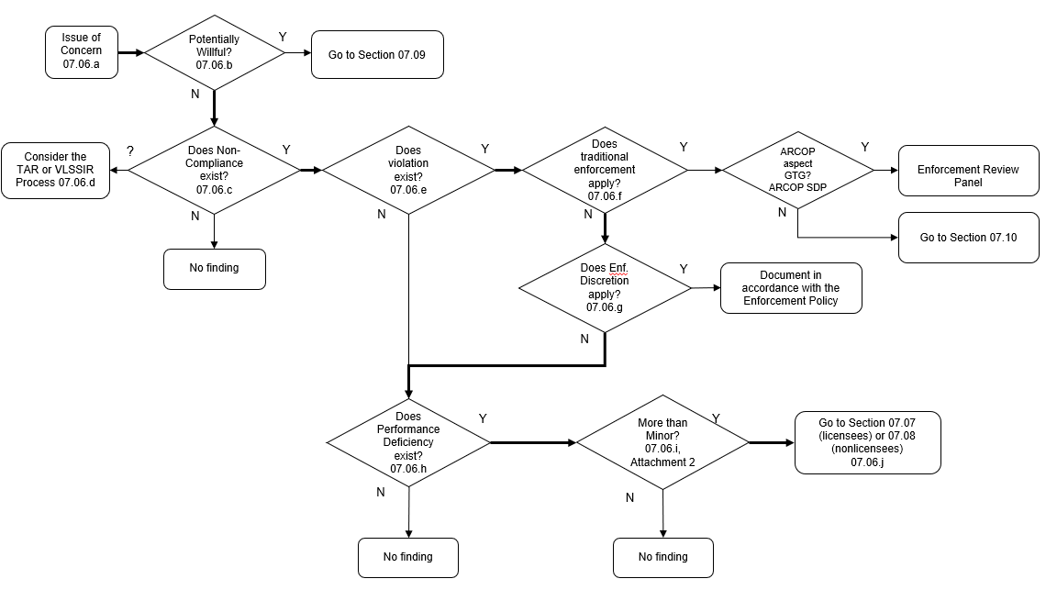

07.07 Dispositioning Licensee Findings
Disposition licensee findings using Figures 2 and 2a, and the guidance below:
- NRC-identified or self-revealed finding: At this point in the screening process, the finding is either NRC-Identified or self-revealing since it has been screened to determine if it is an SCN in Section 07-06.
- Legally binding requirement?
  - Findings associated with legally binding requirements (see definition of “noncompliance” in Section 2571-04) are normally documented with an associated violation.
  - Findings associated with a licensee’s failure to satisfy a non-legally binding requirement (e.g., self-imposed standards, or codes and standards used by the licensee but not legally required as part of their licensing basis) are not documented with a violation.
- Determine the safety or security significance of the finding. NRC staff shall use Attachment 3 to determine the significance of ARCOP findings.
- Dispositioning Greater than Green Findings: If the significance of the finding is potentially greater than green, enter the Enforcement Review Panel process. The Enforcement Review Panel is responsible for determining the final significance of the finding.
- If the finding is screened as green, then determine if the requirements for issuing an NCV are met. If the requirements for issuing an NCV for the associated violation are not met, then disposition the associated violation as an NOV.
If a licensee has implemented a CAP that is determined to be adequate by the NRC, then the NRC will normally disposition SL-IV violations (including those associated with green ARCOP findings) as NCVs if all the criteria in paragraph 2.3.2.a of the Enforcement Policy are met.
- If the finding is not associated with a legally binding requirement, then determine the safety or security significance of the finding. NRC staff shall use Attachment 3 to determine the significance of the finding.
- For green findings without violations, determine if the NRC has reviewed the licensee’s CAP and determined it to be effective. See IMC 2574 for details of NRC CAP reviews for construction licensees.
If the licensee’s CAP has been reviewed and is adequate, then disposition the finding as a green Finding (FIN). If not, then disposition the finding with an associated notice of deviation (NOD). Confidence in the licensee’s CAP facilitates closing green FINs without a formal review by the NRC staff. The NRC staff will review NOD responses and may reinspect issues prior to NOD closure.

Figure 2: Dispositioning Licensee Findings
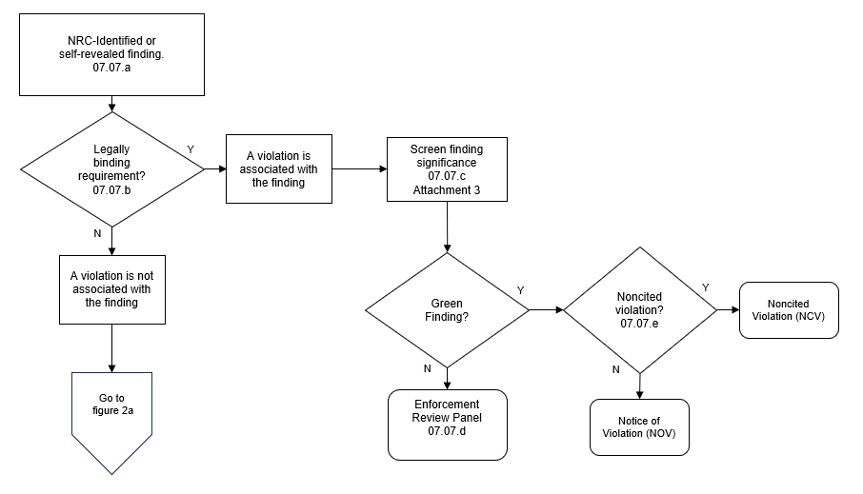

Figure 2a: Dispositioning Licensee Findings (continued)
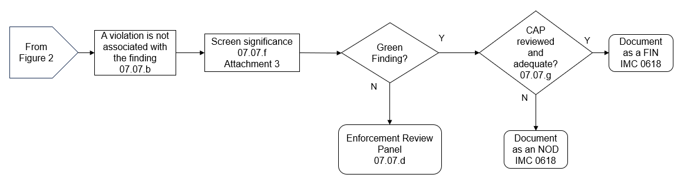

07.08 Dispositioning Non-Licensee Findings
Disposition non-licensee findings using Figure 3, and the guidance below. Note that non-licensee noncompliances that are violations of directly imposed NRC requirements (e.g., 10 CFR Part 21) are dispositioned using TE following the directions of Section 07.06 and Figure 1, “Initial Screening of Noncompliances.
- At this point in the screening process, the finding is either NRC-Identified or self-revealing since it has been screened to determine if it is an SCN in Section 07-06.
- Document the finding as an NON to the project vendor. Use the guidance in the Enforcement Manual and IMC 0618 to document the NON.
- Evaluate the finding using the screening criteria in the ARCOP SDP and use this information to determine appropriate follow-up actions in accordance with IMC 2572.

Figure 3: Dispositioning Non-Licensee Findings
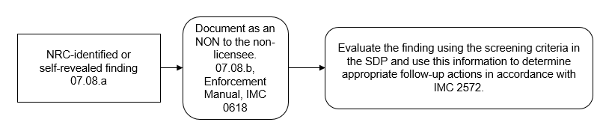

07.09 Dispositioning Noncompliances Involving Potential Willfulness
The term “willfulness” as used in the Enforcement Policy refers to conduct involving either a careless disregard for requirements, a deliberate noncompliance with requirements, or falsification of information.
Willful violations are of particular concern because the NRC’s regulatory program is based on licensees and their contractors, employees, and agents acting with integrity and communicating with candor. If willfulness is suspected, inspectors shall inform the inspection team lead and their supervisor, then enter the issue into the allegation process in accordance with Management Directive (MD) 8.8, “Management of Allegations.”
Further actions, such as screening the issue for safety or security significance and determining the final disposition of the issue will be directed by the Allegation Review Board (ARB) and the Office of Enforcement - including the NRC Regional OE representative if applicable.

07.10 Dispositioning Non-Willful TE Noncompliances
- TE is used to disposition noncompliances in the situations below:
  - Noncompliances that resulted in actual safety or security consequences: Actual safety or security consequences should be rare during construction of reactor plants; however, examples may include an actual onsite or offsite release of radionuclides exceeding regulatory limits, onsite or offsite radiation exposures exceeding regulatory limits, accidental criticalities, loss of control of special nuclear material, or loss of control of radiological material exceeding regulatory limits for public dose.
  - Noncompliances that may impact the ability of the NRC to perform its regulatory oversight function, for example:
    - failure to receive prior NRC approval for changes in licensed activities,
    - failure to notify the NRC of changes in licensed activities,
    - failure to perform 10 CFR 50.59 or 10 CFR 52.98 analyses,
    - submittal and NRC acceptance of an ITAAC Closure Notification (ICN) that states that an ITAAC acceptance criterion is met when it is not met,
    - failure to make required reports to the NRC.
  - Noncompliances not associated with an ARCOP technical issue: ARCOP noncompliances are those that are associated with ARCOP safety or security cornerstones.
  - Violations with no performance deficiency: TE is used to disposition violations with no performance deficiency (i.e., the noncompliance was not within the licensee’s or non-licensee’s ability to foresee and correct). This is not common for construction noncompliances, and a “no performance deficiency” determination should be coordinated with the Office of Enforcement and the ARCOP Project Office.
- TE is used to disposition findings with associated violations that cannot be addressed solely through the ARCOP significance determination process since they include TE aspects. In these cases, the ARCOP safety or security significance of the finding is used to inform the final severity level of the violation. Use Figure 4 and the guidance below to disposition these violations:
  - Determine if the TE violation is more than minor. If the answer to any of the following questions is “yes,” then the TE violation is more than minor.
    - Did the TE violation result in an actual consequence?
The NRC Enforcement Policy, Section 2.2.1.a, lists several examples of actual consequences. Some of the examples in the NRC Enforcement Policy do not apply to reactors under construction since there is no reactor core, no fission product source, no barriers required to contain fission products, and no required emergency response plan. However, construction of advanced reactors may involve possession of radioactive or special nuclear material. The list of examples below is a subset of the examples in the NRC Enforcement Policy to take these considerations into account. The TE violation resulted in an actual consequence if:
- There was an on-site or off-site release of radionuclides or a radiation exposure which exceeded 10 CFR Part 20, “Standards for Protection Against Radiation,” regulatory limits, or
- There was an on-site or off-site chemical hazard exposure resulting from a licensed or certified activity, or
- There was a loss of control of radioactive or special nuclear material, or
- A security system malfunctioned and, because of the failure, a significant event or an event that resulted in an act of radiological sabotage occurred.
    - Does the TE violation represent a more than minor impact on the NRC’s ability to perform its regulatory oversight function?
The NRC considers the safety and security implications of noncompliances that may affect the NRC’s ability to carry out its regulatory oversight function. The NRC Enforcement Policy, Section 2.2.1.c lists several examples of noncompliances that represent a more than minor impact on the NRC’s ability to perform its regulatory function. Further, Section 6.9 of the Enforcement Policy lists criteria for SL-IV, SL-III, SL-II, and SL-I construction violations. The questions below are derived from this guidance.
If the answer to any of the questions below is “yes,” then the violation may be greater than minor. However, recognizing that the regulation of nuclear activities in many cases does not lend itself to a mechanistic treatment for determining significance of these types of violations, judgment must be exercised in determining the SLs of the violations and the appropriate enforcement sanctions. The APO and the OE should be consulted prior to finalizing a determination that a noncompliance is greater than minor due to it affecting the NRC’s ability to carry out its regulatory oversight function.
      - Did the TE violation include a failure to provide complete and accurate information, such as a failure to perform 10 CFR 50.59, “Changes, Tests and Experiments,” or similar analyses; failures to maintain an up-to-date and accurate FSAR; or a failure to comply with reporting requirements, and did this failure to provide information result in the NRC taking a regulatory action, or failing to take a regulatory action, that was different than the NRC would have taken had this information been available to them?
      - Did the TE violation include a failure to receive prior NRC approval for changes in licensed activities, when required; or a failure to notify the NRC of required changes in licensed activities, when required?
      - Did the TE violation result in an NRC-accepted ITAAC closure notification (ICN) that is not valid either because the licensee did not meet the acceptance criteria or the performance of an inspections, tests, or analyses upon which the acceptance criteria are based is not valid?
Note: this scenario is different from situations where the ITAAC requirements were met at the time the ICN was submitted but subsequent testing or analyses demonstrated the ITAAC acceptance criteria no longer continue to be met. This second scenario is covered under ITAAC maintenance and may require the licensee to submit an ITAAC Post Closure Notification (IPCN).
      - Did the TE violation meet any other criteria in Section 6.9 of the NRC Enforcement Policy for being SL-IV or higher?
      - If no performance deficiency is associated with a violation, does the violation screen as more than minor using Attachment 2 of this IMC?
  - ARCOP safety or security significance of the noncompliance: Use Attachment 3 of this IMC to determine the ARCOP safety or security significance of the finding, if possible. This information will inform the final severity level determination of the violation. Some TE violations may have no ARCOP technical aspect. For these violations, the ARCOP significance is not applicable.
  - Final severity level of the violation: The final severity level of the violation is determined using the NRC Enforcement Policy section 6 guidelines, considering the ARCOP safety or security significance of the finding. If the Enforcement Policy severity level and the ARCOP safety or security significance are not aligned, then consult with OE and APO prior to assigning the final severity level of the violation.

Figure 4: Dispositioning Non-Willful TE Violations
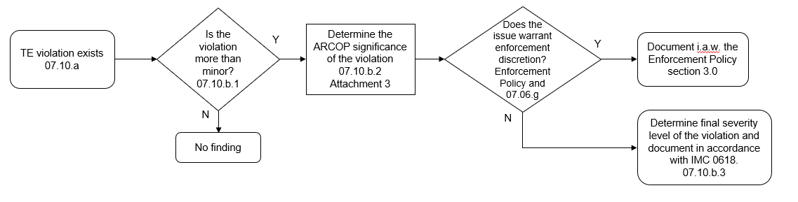

07.11 Enforcement Review Panel Procedures
The Enforcement Review Panel provides a management review of inspection findings, a preliminary decision regarding the significance characterization, and enforcement recommendations for all inspection findings in which the proposed significance characterization is White, Yellow, or GTG. An official agency preliminary significance determination of White, Yellow, or GTG can only be made by an Enforcement Review Panel. When necessary, based on the results of a Regulatory Conference or written response provided by the licensee, the Enforcement Review Panel provides the management review and a final decision regarding the finding’s significance determination and enforcement action, as applicable. The Enforcement Review Panel process is described in the NRC Enforcement Policy.
If the recipient of an NRC enforcement or administrative action disagrees with the staff’s final determination of significance or severity level for an ARCOP finding, they may appeal the determination to the Director of APO as described in Attachment 4 of this Manual Chapter. Any such review must meet the requirements stated in the Prerequisites and Limitations Sections of Attachment 4 to merit further staff consideration. Specifically, the recipient must have opted for an opportunity to present additional information to the staff either by meeting with NRC management at a Regulatory Conference or by submitting a written response on the docket.

2571-08 REFERENCES
- IMC 2572, “Assessment of Advanced Reactor Construction Projects.”
- IMC 2573, “Inspection of The Advanced Power Reactor “Quality Of Reactor Plant Construction” Strategic Performance Area.”
- IMC 2574, “Inspection of The Advanced Power Reactor “Operational Readiness” Strategic Performance Area.”
- NRC Enforcement Policy
- NRC Enforcement Manual
- IAEA SSR-2/1, revision 1, “Safety of Nuclear Power Plants: Design.”
- IMC 0609, “Significance Determination Process.”
- IMC 2203, “Security Inspection Program for Advanced Power Reactor Construction.”
- NEI 08-01, revision 5, “Industry Guideline for the ITAAC Closure Process under 10 CFR Part 52,” July 2013.
- NEI 18-04, revision 1, “Risk-Informed Performance-Based Technology Inclusive Guidance for Non-Light Water Reactor Licensing Basis Development,” August 2019.
- SECY-25-0103, “Update on Development of the U.S. Nuclear Regulatory Commission’s Advanced Reactor Construction Oversight Program,” dated December 16, 2025 (ML2502A243).
- SECY-23-0048, “Vision for the Nuclear Regulatory Commission’s Advanced Reactor Construction Oversight Program,” dated June 6, 2023 (ML23061A086).
END
List of Attachments:
Attachment 1: Acronyms
Attachment 2: Determining if an ARCOP Noncompliance is Minor
Attachment 3: ARCOP Finding Significance Determination
Attachment 4: Process for Appealing an NRC SDP Determination
Attachment 5: Alternate Significance Determination
Attachment 6: Revision History for IMC 2571

Attachment 1: Abbreviations
APO ARCOP Project Organization
ARB Allegation Review Board
ARCOP Advanced Reactor Construction Oversight Program
AV Apparent Violation
CAP Corrective Action Program
CFR Code of Federal Regulations
COL Combined License
CP Construction Permit
FIN Finding
FSF Fundamental Safety Function
GTG Greater Than Green
ICN ITAAC Closure Notification
IMC Inspection Manual Chapter
ITAAC Inspections, Tests, Analyses, and Acceptance Criteria
LWA Limited Work Authorization
ML Manufacturing License
NCV Non-Cited Violation
NOD Notice of Deviation
NON Notice of Nonconformance
NOV Notice of Violation
NRC Nuclear Regulatory Commission
NRR Office of Nuclear Reactor Regulation
OE Office of Enforcement
OGC Office of the General Counsel
OI Office of Investigations
OL Operating License
QA Quality Assurance
QAP Quality Assurance Program
SCN Self-identified Construction Noncompliance
SDP Significance Determination Process
SL Severity Level
SSC Structure, System or Component
TAR Technical Assistance Request
TBD To Be Determined
TE Traditional Enforcement
URI Unresolved Item
VLSSIR Very Low Safety Significance Issue Resolution

Attachment 2: Determining if an ARCOP Noncompliance is Minor
Minor noncompliances include noncompliances below the significance associated with green findings, SL-IV violations, or non-licensee noncompliances warranting issuance of a Notice of Nonconformance (NON). Minor noncompliances cannot be potentially willful and are not the subject of formal enforcement or administrative actions. The NRC usually does not document minor noncompliances. Refer to IMC 0618, “Advanced Power Reactor Construction Inspection Reports,” for guidance on when it may be appropriate to document minor noncompliances. This attachment addresses ARCOP noncompliances and does not address traditional enforcement (TE) violations. Guidance for determining if a TE violation is minor is in Section 07-10.
NRC staff uses Attachment 2, Figure 2.1, and the guidance below to determine if an ARCOP noncompliance is minor. Examples of minor and more than minor noncompliances are given at the end of this attachment. These examples are intended to be an aid to NRC staff and should not be solely relied upon to determine if a noncompliance is minor or more than minor. Note that at this point in the screening process, the noncompliance has already been screened for a Self-identified Construction Noncompliance (SCN). Therefore, noncompliances entering the screening process of this attachment must be either NRC-identified or self-revealing.
The minor/more than minor (MTM) criteria below are focused on the noncompliance’s impact on the functionality of safety-related or safety-significant SSCs. While noncompliances that do not significantly impact SSC functionality are minor, license and permit holders must correct minor noncompliances. Corrective actions may consist of replacing the SSC, repairing the SSC, analyzing and justifying an as-built configuration with the noncompliance present, or redesigning the SSC so that the condition is no longer a noncompliance. Some corrective actions may require NRC approval via a licensing action.
Functionality, as used in this IMC, is the ability of an SSC to fulfill its safety-related and safety-significant functions. SSCs are often built in accordance with codes and standards rather than having detailed design-specific construction requirements. For example, a combined license (COL) or construction permit (CP) may reference the American Concrete Institute (ACI) codes and standards when specifying requirements for the placement of concrete. A noncompliance with a referenced code or standard calls into question the functionality of the affected SSCs. However, some code or standard noncompliances may not impact SSC functionality and are minor.
When determining if a noncompliance prevents an SSC from meeting functionality requirements, inspectors should not perform, or request that license or permit holders perform a detailed functionality determination. Inspectors should use engineering judgement to determine if the noncompliance would reasonably impact SSC functionality. If the inspector cannot determine a noncompliance’s impact on SSC functionality without a detailed analysis, then SSC functionality should be considered indeterminate, and the issue is more than minor. Inspectors are expected to be able to make the minor/MTM designation by the end of the inspection. License and permit holders are expected to pursue corrective actions for the noncompliance in either case.
For noncompliances that impact ITAAC, inspectors should use the same approach for minor/MTM determinations as non-ITAAC noncompliances except that they should also determine the impact on the validity of the inspection, test, or analysis (ITA) upon which the ITAAC acceptance criteria are based. If the ITAAC ITA results are invalidated by the noncompliance, then the noncompliance is MTM because the functionality of the associated SSC is indeterminate.
If the noncompliance prevents the ITAAC AC from being met, but affected SSCs remain functional, then the noncompliance is minor. This scenario may occur when the ITAAC AC references a code or standard. For example, an ITAAC AC that says “A report exists and concludes that the SSC meets the specifications of code or standard” would not be met if a noncompliance with the code or standard exists, but if the noncompliance does not prevent the SSC from meeting functionality requirements, then the noncompliance is minor. Inspectors should not confuse minor ITAAC noncompliances with the ITAAC AC being met. A noncompliance may be minor, but if the corresponding ITAAC AC is not met, then the ITAAC cannot be closed until the noncompliance is corrected.
Licensees must correct minor noncompliances. If a licensee does not disposition a minor noncompliance in accordance with its quality assurance program, then NRC staff should screen this as a new noncompliance.

Figure 2.1: Determining if an ARCOP Noncompliance is Minor

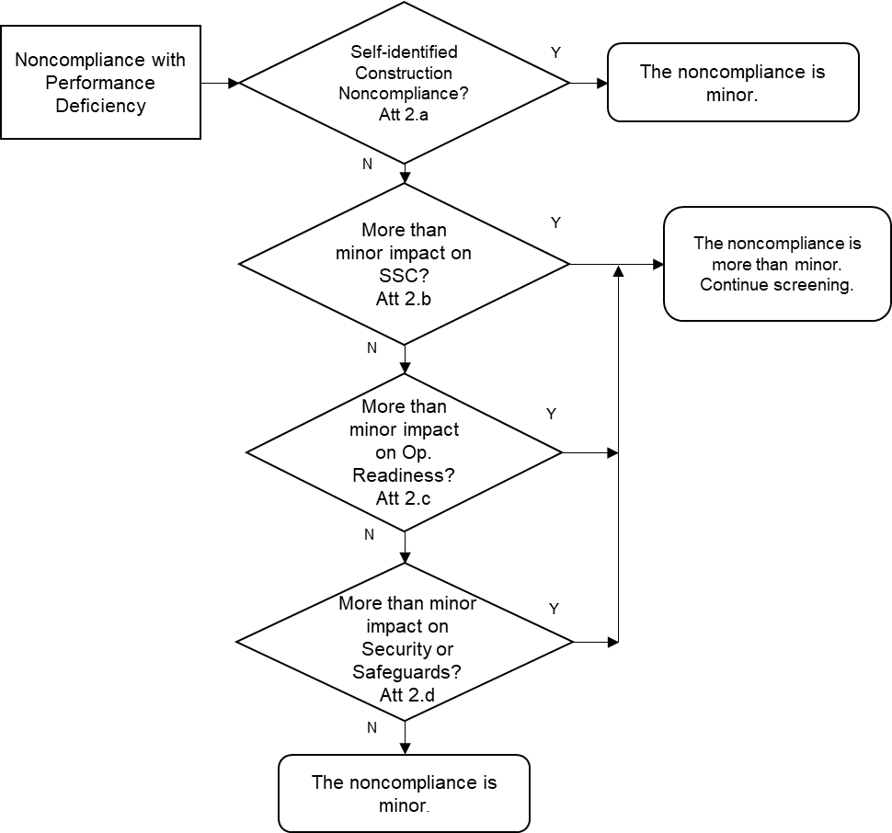

- Is the noncompliance a self-identified construction noncompliance (SCN)? See Section 07.02 of this IMC for criteria in determining if a noncompliance is an SCN.
- Does the noncompliance have a more than minor impact on a safety-significant (SR or a non-safety related, safety-significant (NSRSS)) SSC? Answer this question yes if the answer to any of the following questions is answered yes.
  - Does the noncompliance prevent a safety-significant SSC from performing its safety-significant function or make its functionality indeterminate?^{1, 2}
  - Does the noncompliance prevent meeting an ITAAC acceptance criterion, and does the noncompliance prevent a safety-significant SSC from performing its safety-significant function, or make its functionality indeterminate?^{1, 2}
  - Does the noncompliance invalidate the results of an Inspection, Test, or Analysis described in an ITAAC?³
Note 1: It is not the intent of these criteria that an extensive functionality determination be completed. If substantive analysis is required to determine functionality, then the issue is MTM.
Note 2: An SSC is functional if it can meet its safety-significant function during all applicable licensing basis events for which it is credited. LBEs include internal and external hazards.
Note 3: This only applies to ITA results that were first considered acceptable and later determined to be invalid based on the noncompliance being screened. If the ITA results were originally determined to be unacceptable, then the noncompliance is minor.
- Does the noncompliance represent a more than minor impact on the ARCOP Strategic Performance Area of “Operational Readiness?” Answer this question yes if either of the following questions are answered yes:
  - Does the noncompliance impact the functionality of a safety-significant SSC, and is the answer to any of the questions b.1 through b.3 above answered “yes?”
  - Does the noncompliance represent a substantive failure¹ to implement² an adequate operational program, process, procedure, or quality oversight function?
Note 1: “substantive failure” in this context means that the impact on the operational program is such that the program’s effectiveness is reduced in fulfilling one of the program’s objectives. The program’s objectives may be found in program documents, regulations, technical specifications, site technical requirements documents, construction permits (CPs), Operating License (OL) applications, and/or combined licenses (COLs).
Note 2: an operational program is implemented when it is required to be activated by a license or permit condition, or by NRC regulations. NRC audits of operational or security programs prior to program implementation are not subject to enforcement.
- Does the noncompliance represent a more than minor impact on the ARCOP Strategic Performance Area of Safeguards and Security? Answer this question yes if the following question is answered yes:
Does the noncompliance represent a substantive failure¹ to establish or implement² an adequate security program³, process, procedure, or quality oversight function?
Note 1: “substantive failure” in this context means that the impact on the security program is such that the program’s effectiveness is reduced in fulfilling one of the program’s objectives.
Note 2: a security program is implemented when it is required to be activated by a license or permit condition or by NRC regulations. NRC reviews of operational or security programs prior to program implementation are not subject to enforcement.
Note 3: Security programs include access authorization, access control (including fitness for duty), physical protection, contingency response, material control & accountability, cyber security, and protection of safeguards information.

Minor ARCOP Noncompliance Examples
The minor examples described in this attachment are meant to represent examples of noncompliances that should normally be considered minor significance. While the examples provide a “not minor if” statement, this does not mean that all issues like the “not minor if” statement should automatically be classified as more than minor. The overall purpose of these questions is to help inspectors know what kinds of issues should be minor. Issues that don’t immediately screen as minor with these examples need to be further evaluated. NRC staff should consult with the ARCOP project organization (APO) if the minor/more-than-minor significance cannot be readily determined.
Type of Noncompliance | Examples
As-built SSCs (non-ITAAC) | 1a
As-built SSCs (ITAAC) | 1b
Design Requirements | 2
QA Records | 3
Quality Control Inspection | 4
Procedure Use | 5
Procedure Content | 6
Supplier Oversight | 7
Testing Acceptance Criteria | 8
Material Control | 9
Corrective Actions | 10
Computer Software | 11
Code Requirement (non-ITAAC) | 12a
Code Requirement (ITAAC) | 12b
Measuring and Test Equipment | 13
Operational Programs | 14, 15
Security Programs | 16

Example 1a: As-Built SSCs (non-ITAAC related)
Noncompliance:
The inspectors identified that an as-built SSC did not meet an applicable design or construction specification.
Minor because:
The as-built SSC was functional even though it did not conform to the specification, and this was evident without a significant engineering evaluation; or
The as-built SSC was more conservative than the as-designed SSC.
Not minor if:
The functionality of the as-built SSC was impaired or indeterminate without a substantive engineering evaluation.
Example 1b: As-Built SSCs (ITAAC related)
Noncompliance:
The inspectors identified that an as-built SSC did not meet the applicable design or construction specification, which prevented the ITAAC AC from being met.
Minor because:
The as-built SSC was functional without the support of detailed engineering justification,
Not minor if:
The functionality of the as-built SSC was impaired or indeterminate without a substantive engineering justification.
Example 2: Design Requirements
Noncompliance:
The inspectors identified that the license or permit holder’s design specification did not conform to the design basis (i.e., the license or permit holder failed to adequately translate the approved design to appropriate drawings, instruction, procedures, etc.).
Minor because:
The design error resulted in a more conservative analysis than what was required by the governing technical requirements; or
The design error was insignificant, in that the ability of the SSC to perform its intended safety-related or safety-significant function was not impaired.
Not minor if:
The design error resulted in a less conservative analysis that made the SSC’s ability to perform its safety-related or safety-significant function indeterminate without a detailed engineering evaluation.
Example 3: QA Records
Noncompliance:
The inspectors identified that the license or permit holder failed to maintain quality assurance records in accordance with QA program requirements.
Minor because:
No records were irretrievably lost; or
The lost records were not relied upon to demonstrate functionality of the SSC.
Not minor if:
Records were lost or damaged to an extent that prevents the license or permit holder from demonstrating that a safety-related or safety-significant SSC was functional and therefore renders the SSC’s functionality indeterminate.
Example 4: QC Inspection
Noncompliance:
The inspectors identified that a license or permit holder’s quality control (QC) inspector was not qualified in accordance with the QA program requirements.
Minor because:
The QC inspector’s unqualified status was a result of an administrative issue; or
The QC inspector did not perform an inspection of an SSC in the area of qualification in question; or
When reinspected by a qualified inspector, all SSCs were acceptable.
Not minor if:
A reinspection resulted in the identification of a nonconforming condition that made the SSC nonfunctional; or
The SSC was not able to be reinspected and required a detailed engineering evaluation to justify its acceptability.
EXAMPLE 5: Procedure Use
Noncompliance:
The inspectors identified that welding was performed with a parameter (e.g., electrode size) outside that allowed by the welding procedure specification (WPS).
Minor because
The parameter in question was not an essential variable as defined by the code and the as-installed weld was acceptable.
Not minor if:
The parameter in question was an essential variable and the weld required significant repair (i.e., grinding out and reperforming the weld).
EXAMPLE 6: Procedure Content
Noncompliance:
The inspectors identified that a manufacturing or construction procedure was not adequate.
Minor because:
The issue was insignificant, in that the procedure was inadequate because of an administrative error or other deficiency that did not affect an SSC’s functionality; or
Not minor if:
The procedure didn’t adequately implement a technical or quality requirement that makes an SSC’s functionality unacceptable or indeterminate.
EXAMPLE 7: Supplier Oversight
Noncompliance:
The inspectors identified that the license or permit holder failed to conduct a required surveillance of their supplier.
Minor because:
The license or permit holder had established adequate measures to control purchased items and services (i.e., no SSC was of indeterminate functionality).
Not minor if:
The license or permit holder received and accepted nonconforming material that made an SSC nonfunctional or made the SSC’s functionality indeterminate, and the surveillance could have identified the deficiency in the vendor’s program.
EXAMPLE 8: Testing Acceptance Criteria
Noncompliance:
The inspectors identified that the license or permit holder failed to recognize that a test acceptance criterion was not met.
Minor because:
The acceptance criterion was more conservative than the governing regulatory requirement, which was met; or
The test criterion was not consequential because it was not necessary to demonstrate SSC functionality.
Not minor if:
Failing to meet the acceptance criterion made the SSC’s functionality unacceptable or indeterminate without a detailed engineering evaluation.
EXAMPLE 9: Material Control
Noncompliance:
License or permit holder procedures require that all safety-related and safety-significant structural steel be stored off the ground to prevent corrosion. The inspectors identified structural steel that was lying directly on the ground.
Minor because:
The steel has no damage that would require a detailed engineering evaluation to determine the adequacy of the structural steel to perform its intended safety-related or safety-significant function.
Not minor if:
The structural steel was damaged such that a detailed engineering evaluation, re-design, or repair was necessary to establish the adequacy of the structural steel to perform its function.
EXAMPLE 10: Corrective Actions
Noncompliance:
The inspectors identified that the license or permit holder failed to initiate a noncompliance report for a self-identified noncompliance discovered during an inspection of an SSC.
Minor because:
The issue meets the criteria for a Self-identified Construction Noncompliance (SCN) since workers met the QAP requirements for documentation and/or resolution of the noncompliance through other means; or
The noncompliance does not make functionality of an SSC unacceptable or indeterminate.
Not minor if:
The issue does not meet the criteria for a Self-identified Construction Noncompliance (SCN) because the workers failed to meet the QAP requirements for documentation and resolution of the noncompliance, and the noncompliance makes an SSC’s functionality unacceptable or indeterminate.
EXAMPLE 11: Computer Software
Noncompliance:
The inspectors identified an anomaly in the Software Requirement Specification which was inconsistent with system requirements.
Minor because:
The anomaly does not make a safety-related or safety-significant system nonfunctional or of indeterminate functionality; or
The anomaly was more conservative than the system requirements.
Not minor if:
The anomaly makes a safety-related or safety-significant SSC’s functionality unacceptable or indeterminate.
EXAMPLE 12a: Code Requirement (not ITAAC related)
Noncompliance:
The inspectors identified that the license or permit holder failed to meet a code requirement specified in the licensing basis.
Minor because:
The code noncompliance did not make the functionality of the SSC unacceptable or indeterminate, or
The as-built SSC was more conservative than the design requirements.
Not minor if:
Functionality of the SSC could only be demonstrated by performing a detailed engineering evaluation.
EXAMPLE 12b: Code Requirement (ITAAC related)
Noncompliance:
The inspectors identified that the license or permit holder failed to meet a code requirement specified in the acceptance criteria of an ITAAC.
Minor because:
The code noncompliance did not make the functionality of the SSC unacceptable or indeterminate; or
The as-built SSC was more conservative than the design requirements.
Not minor if:
The SSC was not functional or functionality could only be demonstrated with a detailed engineering evaluation.
EXAMPLE 13: Measuring and Test Equipment (M&TE)
Noncompliance:
Equipment used during testing was found to not meet procedure requirements (e.g., the M&TE was not calibrated within the required periodicity).
Minor because:
Subsequent testing with correctly calibrated MT&E showed that the original test results were more conservative or did not substantially alter the test results, or
The MT&E was later found to be in calibration when checked.
Not minor if:
Subsequent testing with the correct MT&E results in a nonconservative substantial change in the test results (e.g., a test that passed previously now fails to meet the acceptance criteria); or
The use of incorrect test equipment resulted in substantial damage to an SSC.
EXAMPLE 14: Operational Program Nonconformance
Noncompliance:
Fire protection equipment is not installed according to design drawings.
Minor because:
The fire protection program has not been implemented, or
The fire protection program has been implemented, but the fire protection equipment is installed in a manner that supports all fire protection program objectives. In other words, the functionality of the fire protection equipment is unaffected by the installation noncompliance and adequate equipment protection from fires is maintained.
Not minor if:
The fire protection program has been implemented, and the functionality of the fire protection equipment is affected such that the level of protection of equipment from fires is not adequate.
EXAMPLE 15: Operational Program Nonconformance
Noncompliance:
A plant procedure for conducting radiological releases from the plant as part of the radiological effluent monitoring program (REMP) references incorrect radiation monitoring instrumentation.
Minor because:
The REMP has not been implemented, or
The REMP has been implemented, and the procedure reference is a typographical error, and the correct instrumentation would be readily apparent and available when conducting releases, or
The REMP has been implemented, and the instrumentation is not relied on to accurately characterize the radiological release.
Not minor if:
The REMP has been implemented, and accurate instrumentation is not available to characterize a radiological release.
EXAMPLE 16: Security Program Noncompliance
Noncompliance:
A document containing Safeguards Information was mailed incorrectly.
Minor because:
A document containing Safeguards Information was mailed and the cover letter transmitting the Safeguards document failed to contain the appropriate Safeguards Information headers/footers and decontrol markings; however, the safeguards document was appropriately controlled.
Not minor if:
A document containing Safeguards Information was mailed and the package was not properly tracked through a commercial delivery company, and it took the licensee several days to realize the document was delivered to the incorrect mailing address.
EXAMPLE 17: Fitness for Duty (FFD) Program Noncompliance
Noncompliance:
A group of workers at the site were not placed in the random testing program for construction.
Minor because:
A subsequent review of the work performed by the individuals identified that they did not perform work on safety-significant or security-related SSCs.
Not minor if:
A subsequent review of the work performed by the individuals identified that they worked on safety-significant or security-related SSCs, and inspection of their work activities identified conditions which adversely affected functionality or qualification of the SSCs; or
A drug/alcohol test confirmed that an individual was in violation of the FFD policy while working on safety-significant or security-related SSCs.

Attachment 3: ARCOP Finding Significance Determination
The guidance in this attachment shall not be used without first performing the initial screening steps specified by Section 07-06.
For findings that impact safety-significant SSCs, use Table 3.1, SSC Significance Determination, and the guidance below. For findings that do not impact safety-significant SSCs (i.e., the finding only affects non-hardware elements or non-safety-significant hardware used to support implemented programs), use the appropriate Reactor Oversight Process (ROP) SDP. If the finding affects more than one strategic performance area, then screen the finding using both methods and use the highest significance for the significance of the finding.
Identify the appropriate criterion in Table 3.1 for the finding and use the corresponding significance color. If the finding initially screens as green, then green is its final significance. If the finding initially screens as white or yellow, then enter the Enforcement Review Panel. Only an Enforcement Review Panel can designate the final significance of a finding to be white, yellow, or GTG.

Table 3.1: SSC Significance Determination
Significance of Finding | Finding’s Impact on SSCs
Yellow | The finding, if left uncorrected, would result in the inability to fulfill multiple FSFs¹.  Or  The finding’s significance cannot be adequately screened using other criteria in this table and has screened as Yellow using Attachment 5².
White | The finding, if left uncorrected, would result in the inability to fulfill one FSF¹  Or  The finding’s significance cannot be adequately screened using other criteria in this table and has screened as White using Attachment 5².
Green | a. The finding, if left uncorrected, would result in the loss of a safety-significant function(s) of one or more SSCs, but all FSFs are fulfilled; or  b. the finding is associated with an issue where no manufacture, fabrication, placement, erection, installation, or modification of hardware associated with the SSC has begun; or  c. There is a quality assurance program (QAP) backstop³ for the deficiency associated with the finding; or  d. the finding is associated with a hazard protection feature⁴ only; or  e. The finding’s significance cannot be adequately screened using other criteria in this table and has screened as Green using Attachment 5².

Note 1: Fundamental safety functions (FSFs). FSFs are defined by NEI 18-04, revision 1, “Risk-Informed Performance-Based Technology Inclusive Guidance for Non-Light Water Reactor Licensing Basis Development (endorsed by RG 1.233) to be:
- Control of Heat Generation (Reactivity and Power Control),
- Control of Heat Removal (including reactor and spent fuel decay heat), and
- Radionuclide Retention.
While NEI 18-04 was written specifically for non-LWRs, FSFs are also applicable to LWRs. A complete loss of an FSF occurs if SSCs impacted by the finding are required to fulfill the FSF and the SSCs are not merely redundant to an inherent design feature. In general, if the finding affects only one SSC, then the finding will not cause the loss of an FSF due to defense-in-depth (DID) requirements. A finding that affects multiple SSCs may or may not cause the loss of an FSF. If the FSF can be fulfilled by DID (i.e., other SSCs or design features), then the finding does not cause a loss of an FSF. If inspectors are unsure of the impact on FSFs, they should inform their supervisor and seek guidance from the ARCOP Program Organization (APO).
For the radionuclide retention FSF, a complete loss of the FSF only occurs if the finding causes the loss of the ability to retain fission products from irradiated reactor fuel. This does not include fission products in systems, such as cover gas systems or coolant purification systems, that may contain trace amounts of fission products during normal operations.
Note 2: Findings not adequately addressed by safety significance criteria. When the ARCOP construction significance determination process guidance is not adequate to provide a reasonable estimate of the significance of an inspection finding, the safety significance should ultimately be determined by using engineering judgement and regulatory oversight experience, which is acceptable in a risk-informed process. Attachment 5 provides guidance to the NRC to apply a consistent process for risk-informed decision making.
Note 3: Quality assurance program (QAP) backstop. A QAP backstop is a scheduled QAP activity designed to detect SSC deficiencies or noncompliances that are associated with the finding. To give credit for a QAP backstop, the QAP activity must be reasonably defined or contained in a procedure, scheduled prior to the receipt of an operating license (Part 50) or before the 103(g) finding (Part 52), and able to detect the deficiency or noncompliance associated with the finding with a reasonable degree of certainty.
Note 4: Hazard protection features are those SSCs and design features that mitigate the effects of internal (e.g., fire, flooding, chemical release) or external (e.g., seismic events, fire, flooding, severe weather events) hazards. Findings associated with hazard protection features may also be screened using Attachment 5 if the severity and breadth of the issue warrants additional considerations.

Attachment 4: Process for Appealing an NRC ARCOP SDP Determination
A licensee may appeal the staff’s final significance determination of an ARCOP inspection finding documented in an NRC inspection report or final significance determination letter as White or Yellow. Consistent with the intent of the significance determination process (SDP) to assess significance in a timely manner using the best available information, the staff should be cautious to ensure that the appeal process does not become a protracted review requiring extensive staff resources. This appeal process may be used by ARCOP licensees, permit holders, or project vendors.
It is assumed that prior to issuing the final significance determination and documenting this in an inspection report, including the SDP basis for significance, the staff has completed the following:
- The responsible inspector, applying the best available information, has established the licensee’s noncompliance and characterized the finding as potentially greater than Green. Using the ARCOP SDP, the inspector has determined the proposed preliminary color for the finding (White, Yellow, or Greater Than Green).
- Each finding that the staff’s significance determination has preliminarily characterized “White, Yellow, or Greater Than Green” has been presented to and reviewed by the NRC Enforcement Review Panel. Subsequently, the staff has informed the licensee of the preliminary characterization of the issue in a preliminary significance determination letter which included an invitation for the licensee or project vendor to present additional information.
- If the licensee opted to present additional information to the staff either by meeting with NRC management at a Regulatory Conference or by submitting additional information in writing on the docket, this information has been reviewed and dispositioned by the staff. Additional information that the licensee indicated was not available to present at the Regulatory Conference should be received by the staff within a reasonable period (agreed upon between the licensee and the staff, and documented), to allow the staff adequate time to review the information.
- The staff has sent the licensee a letter which states the staff’s final significance determination and broadly responds to the information provided by the licensee.
Once the above prerequisites have been met, licensee appeals to reduce the significance of an inspection finding will be considered as having sufficient merit for review by this appeal process only if the licensee’s or project vendor’s contention falls into one of the following categories:
- The staff’s significance determination process was inconsistent with ARCOP SDP guidance or lacked justification.
- A licensee submits new information which was not available at the time of the Regulatory Conference. New information will be considered only if the licensee informed the staff that additional information was under development prior to or during the Regulatory Conference, or in their written response to the preliminary significance determination. The information under development should have been received within a reasonable period (agreed upon between the licensee or manufacturer and the staff) for the staff to review it.
The following statement will be added to each inspection report cover letter or other official correspondence that transmits an inspection finding of White or Yellow significance: “You have 30 calendar days from the date of this letter to appeal the staff’s determination of significance for the identified [white/yellow] finding[s]. Such appeals will be considered to have merit only if they meet the criteria given in NRC Inspection Manual Chapter 2571, Attachment 4.”
The licensee must submit its letter of appeal to the applicable Regional Administrator (RA) or to the NRC Office Director responsible for the inspection within 30 calendar days of the date of the transmittal letter. The applicable RA is the Region II RA if the finding was identified during an inspection led by Region II construction inspectors. Otherwise, the applicable RA is the RA of the host region.
The applicable RA or responsible NRC Office Director should determine within 30 calendar days of the receipt of the licensee’s appeal request whether the appeal meets the above limitations. Following the determination, but still within the 30 calendar days, the RA or responsible NRC Office Director should inform the licensee in writing of the decision and its basis.
If the appeal is accepted, the associated review and written notification to the licensee stating the results of the appeal review should be limited to 30 calendar days following the acceptance of the appeal. The applicable RA or responsible NRC Office Director will appoint an appeal panel consisting of, at a minimum, two technical experts in the cornerstone being discussed and an enforcement specialist. The applicable RA or responsible NRC Office Director may also request representation by the Office of General Counsel. At least one panel member will not have had prior involvement with the significance determination under appeal. The principal purpose of the panel is to arrive at a consensus regarding the validity of the licensee’s appeal.
The appeal panel will review the inspection finding, its significance characterization and basis, any new information that was being developed at the time of the Regulatory Conference, and the licensee’s points of contention. The panel may recommend one of the following:
- No further action and the significance determination is unchanged, or
- More detailed justification of the basis for the significance determination is required, or
- Change the significance determination (either increase or decrease), as appropriate.
The appeal panel will provide its conclusions to the Enforcement Review Panel in writing. Within 10 working days of the date of the appeal panel’s conclusions, the Enforcement Review Panel will consider the results of the appeal panel. The Enforcement Review Panel will provide the results of their review to the RA and to the Director of NRR, or the Director of NSIR (for security or emergency planning), within 5 working days.
Within five working days of receiving the final recommendation memorandum, the Regional Administrator and the Director of NRR, or the Director of NSIR (for security or emergency planning) will confer and jointly agree on the final decision. Subsequently the RA or responsible NRC Office Director will notify the licensee in writing of the final agency position.
The results of the appeal process are final with no further avenues for appeal within the significance determination process.

Attachment 5: Alternate Significance Determination
This attachment provides guidance to NRC management and inspection staff for assessing significance of advanced power reactor construction inspection findings when the advanced reactor construction oversight program (ARCOP) significance determination process (SDP) guidance is not adequate to provide reasonable estimates of the significance of inspection findings within the established SDP timeliness goal of 90 days or less.
A relatively small number of inspection findings may challenge the staff in making timely safety or security significance determinations. In these cases, the safety or security significance of such findings should ultimately be determined using engineering judgement and regulatory oversight experience, which is acceptable in a risk-informed process. This attachment provides guidance to allow the NRC to apply a consistent process using risk-informed decision making.
This attachment is considered only after initial finding screening has been completed in accordance with this IMC, including Attachments 2 and 3. If, based on reasonable assumptions and engineering judgement, a significance conclusion cannot be obtained using the screening criteria in Attachment 3, then this attachment aids in determining the significance of the finding. “Reasonable assumptions and engineering judgement” in this context means that the staff may not be absolutely sure of the assumptions and conclusions, and it is not the intent of this IMC that lengthy calculations or analyses be performed. The guidance in this attachment should be applied when the SDP methods and tools in Attachment 3 are not adequate to determine the significance of the finding within the established SDP timeliness goal of 90 days.
Evaluate the decision attributes in Table 5.1 to determine the significance of the finding. Consider only attributes which relate directly to the significance of the finding and document the basis for these considerations.
- For Green findings, document the finding in accordance with IMC 0618.
- For findings that are screened as white or yellow, include the completed Table 5.1 in the Enforcement Review Panel package.

Table 5.1: Decision-Making Attributes for NRC Management Review
Decision Attribute | Applicable to Decision? | Basis for Input to Decision - Provide relevant information for management review and decision making.
Partial effectiveness of any safety-significant SSCs or design features providing defense in depth for a fundamental safety function (FSF).
The extent to which the finding affects other equipment (e.g., common cause results in widespread construction of degraded or unknown quality for SSCs that support FSFs).
Period the condition existed and failed opportunities to identify the condition during this period (e.g., construction experience, licensee’s quality control program, etc.).
Potential QA backstops not credited in the Attachment 3 analysis, including reason for not crediting them.
Other plant design features that mitigate the significance of the finding.
Any other relevant information impacting significance, such as a probabilistic risk assessment (PRA) if available. Note that a PRA is not required and should not be requested of the licensee.

Result of management review (COLOR):

Attachment 6: Revision History for IMC 2571
Commitment Tracking Number | Accession Number  Issue Date  Change Notice | Description of Change | Description of Training Required and Completion Date | Comment Resolution and Closed Feedback Form Accession Number  (Pre-Decisional Non-Public Information)
N/A | ML25210A579 | Draft IMC for public comment. | N/A | N/A
N/A | ML25336A294  02/05/26  CN 26-004 | Initial Issuance. | Construction Inspector, supervisor and PM ARCOP training | ML25336A292

