NRC INSPECTION MANUAL IRIB
INSPECTION MANUAL CHAPTER 2515 APPENDIX A

RISK-INFORMED BASELINE INSPECTION PROGRAM
Effective Date: July 1, 2025

2515A-01 OBJECTIVES
The baseline inspection program is an integral part of the Nuclear Regulatory Commission (NRC’s) reactor oversight process and supports the goals and objectives of that process. The objectives of the baseline inspection program are:
- To obtain sufficient inspection information to use in conjunction with performance indicators (PI) to assess the safety performance of power reactor licensees.
- To determine the licensee’s ability to identify, assess the significance of, and effectively correct issues commensurate with their risk significance.
- To verify the accuracy and completeness of performance indicators used in conjunction with inspection findings to assess the performance of power reactor licensees.
- Provide a mechanism for the NRC to remain cognizant of plant status and conditions.

2515A-02 PHILOSOPHY OF RISK-INFORMED BASELINE INSPECTION PROGRAM
The baseline inspection program provides indication of licensee performance in areas not measured or not fully measured by performance indicators (PIs) that are reported by the licensees. The program was developed using a risk-informed approach to determine a comprehensive list of areas to inspect within each cornerstone of safety. Those areas are identified as “inspectable areas.” Baseline inspections will (1) verify the accuracy of PI information provided to the NRC by licensees, (2) provide indications of licensee performance in the inspectable areas, and (3) inspect the effectiveness of licensee problem identification and resolution programs. In addition, the baseline program provides for the initial follow up to events.
- Basic Philosophy of the Baseline Program. The following are the philosophical underpinnings of the risk-informed baseline inspection program:
          - The program is indicative and not diagnostic. The baseline program delineates specific inspection activities to evaluate aspects of licensee programs and processes and their implementation by identifying findings that are indicative of licensee performance problems. Inspection findings from the baseline program are evaluated for significance and used, along with performance indicators, to assess licensee performance within the cornerstones of safety. The baseline inspections are not diagnostic assessments of licensee performance leading to a root cause determination. Those assessments and root cause determinations are intended to be reviewed or independently made during supplemental inspections that are outside the scope of the baseline inspection program.
          - The baseline inspection program is risk informed. The risk-informed approach means that inspectable areas were selected based on their significance from a risk perspective. That is, they are needed to meet a cornerstone objective as derived from a combination of probabilistic risk analysis, operational experience, deterministic analyses insights, and regulatory requirements.
Risk has been factored into the baseline inspection program in four ways: (1) inspectable areas are based on their importance in measuring a cornerstone objective, (2) the inspection frequency, how many activities to inspect, and average estimates of how much time it takes inspecting activities in each inspectable area are based on risk information, (3) selection of activities to inspect in each inspectable area is informed by the potential for significance under the significance determination process, and (4) inspectors are trained in the use of risk information.
          - The baseline inspection program is the minimum inspection oversight. The overall objective of the program is to monitor all power reactor licensees with a consistent level of defined requirements to indicate whether licensees’ performance meets the objectives for each cornerstone of safety. The power reactor baseline inspection program defines the planned activities to monitor licensee performance at a minimum level of NRC effort over a 12-month period.
- Key Principles. Three key principles form the foundation of the baseline inspection program:
          - Inspectable areas. Under the baseline inspection program, all areas where there is a need to inspect a licensee’s performance are defined as inspectable areas. Inspections within these areas were adjusted where licensee performance to meet a cornerstone objective is adequately gauged by performance indicators. All the important aspects of a cornerstone area are inspected where a PI has not been established (e.g., design). In cornerstone areas where the PIs provide only limited indication of performance, the inspectable areas provide indication of the aspects not measured (e.g., operator performance during an event). If performance of the cornerstone objective in a cornerstone area is sufficiently measured by a PI, the inspection effort in the baseline program only verifies that the performance indicator is providing the intended data. Attachment 1 presents a listing of inspectable areas associated with each cornerstone of safety.
          - Bases for inspectable areas. Each inspectable area has a basis document, which describes the scope of the inspectable area and explains why the area is included in the baseline program. (See SECY-99-007.) Reasons for inclusion in the program may be that (1) the area is linked to the NRC’s mission, (2) the inspectable area involves a key attribute of a cornerstone of safety, or (3) risk information justifies including the area in the baseline inspection program.
The basis document discusses the basis for each inspectable area and includes risk insights (from generic risk analyses and studies), analyses of significant precursor events, and the risk informed judgment of an expert panel of inspectors and risk analysts. The basis document for each inspectable area also identifies whether a performance indicator applies to the area and what inspections may be needed to supplement or complement the information provided by the performance indicators in the area.
The baseline inspection procedures have been written to focus on the more risk-significant aspects of the inspectable areas as discussed in the basis documents, aspects that directly support the desired results and promote the important attributes of the cornerstones of safety. The scope of any associated PIs is summarized in the inspectable area portions of the baseline inspection procedures.
          - Detailed planning. A third principle in the program is that the regional managers and inspectors plan the type and number of activities to inspect each year for each reactor site, based on the inspection requirements in the inspectable areas and risk informed guidance.

2515A-03 APPLICABILITY
The baseline inspections provide a sufficient examination of licensee activities in order to monitor licensee performance and identify risk-significant issues to assess licensee safety performance. The baseline inspections are performed by the resident and region-based inspectors. It is the intent of the program that in-depth inspections of the emergency preparedness, radiation safety, and physical protection cornerstones will be performed by inspectors qualified in the associated specialty areas in accordance with IMC 1245, “Inspector Qualifications” or as otherwise approved by applicable regional management in accordance with IMC 1245.
The baseline inspection procedures and their attachments define effort and requirements necessary to obtain an adequate assessment of an inspectable area. For resource planning purposes only, each baseline inspection procedure includes an estimate of the inspection hours necessary to complete the procedure. These hours refer to the estimated average times to complete the inspections for cornerstone areas at dual unit sites and show any adjustments for single or triple unit sites, if applicable to the procedure. These estimates are not goals, standards, or limitations; rather, they are included to assist in planning resource allocations, and will be revised periodically, based on experience. It is expected that the actual hours required to complete an individual inspection procedure at a particular plant will vary from the estimate. The program office provides the regional offices with a band of expected effort (approximately 10 percent) for each baseline inspection procedure as a process control. Regional management is expected to review those situations when inspection effort falls outside of the control bands for possible programmatic insights and recommended changes to the program.
Inspectors should inspect to the minimum number of samples specified by the baseline inspection procedure. The specified minimum sample provides the insights necessary to assess performance, with performance indicators, in each cornerstone of safety. Items for consideration to conduct an above-minimum sample are: 1) risk significance of the SSC or evolution, 2) current performance of the licensee, 3) the work the sample will be replacing, and 4) the site has reactors with different technologies (i.e. unique site budget model sites). If the inspectors believe there will be no value added in the assessment of the licensee in conducting samples above minimum, then the inspector should complete Inspection Procedures at minimum samples. Additionally, if the only inspection opportunities for an inspection procedure attachment have very little or no risk or safety significance, then the procedure should not be used at that time. For example, if the only new temporary modifications the licensee has implemented since the last inspection of temporary modifications have no credible significance, the inspector should not spend time completing the inspection requirements on them. (Also see Section 7.b., below.)
Contrarily, the inspector should include the new opportunity into their inspection if a high-risk activity occurs after the inspector has completed an inspection procedure. The reasons for any significant deviations from the sample sizes or estimated hours for completing an inspection should be understood by the inspectors’ supervisor.
Significant findings from the baseline inspections can lead to supplemental inspection activities.

2515A-04 DESCRIPTION OF BASELINE INSPECTION PROGRAM
The risk-informed baseline inspection program is comprised of three parts. They are:
  - Cornerstone-based inspections
  - Verification of performance indicators
  - Identification and resolution of problems
- Cornerstone-Based Inspections. The safety performance of nuclear power plants is assessed based on performance in each cornerstone of safety. Verifying that a licensee meets the objectives of the cornerstones provides reasonable assurance that public health and safety are being protected. The inspectable areas defined in the attachments to the baseline inspection procedures verify aspects of key attributes for each of the associated cornerstones. The cornerstones to which each inspectable area is applicable and their link to the attributes they are measuring is depicted in the cornerstone table and charts in Attachments 1 and 2. Therefore, the baseline inspection program requires that most inspectable areas be reviewed at each nuclear power plant each year. Several are reviewed at longer frequencies.
This portion of the baseline inspection program also accounts for initially screening plant events to determine, based on risk insights, which events will be followed up, and for screening all licensee event reports.
          - Inspection within inspectable areas. Inspections within inspectable areas provide data on licensee performance in areas that are not measured or not fully measured by performance indicators. The inspections are focused into the more risk important aspects of the plant and licensee activities. The basis for, and scope of, inspections within the inspectable areas are summarized in the inspection procedures. They are based on the inspectable area basis documents in SECY-99-007. The procedures also discuss any applicable performance indicators and the areas of inspection credited to the performance indicator.
The baseline inspection procedures are organized by cornerstone with the inspectable areas for initiating events, mitigating systems, and barrier integrity cornerstones in one procedure. The procedures also contain estimated levels of effort and inspection frequencies for the inspectable areas. The cornerstone procedures include attachments that cover all of the applicable inspectable areas although there may not be a one-to-one relationship between the attachments and inspectable areas.
          - Event follow-up. Events of low significance, such as uncomplicated reactor trips, are reviewed by resident or region-based inspectors to verify that the trips are not complicated by loss of mitigation equipment or operator errors. Significant operational events (defined in Management Directive 8.3) are followed up by a graded response consisting of inspections outside of the baseline inspection program, such as those conducted by Incident Investigation Teams (IITs) and Augmented Inspection Teams (AITs), and Special Inspections (SIs). MD 8.3 contains deterministic criteria which are evaluated in conjunction with risk insights to identify the appropriate level of NRC response. The risk metric of Conditional Core Damage Probability (CCDP) is used to best reflect the full extent of any loss of defense-in-depth from the event, regardless of whether the cause is due to licensee performance or otherwise. However, numerical risk estimation by itself is not meaningful unless accompanied by an understanding of the most influential related assumptions and uncertainties.
The baseline inspection program’s event follow-up procedure focuses the inspector’s initial evaluation of events on communicating details regarding the event to risk analysts for their use in determining risk significance. Inspectors will identify equipment malfunctions and unavailability, operator errors, and other complications.
Typically, resident inspectors or region-based specialists initially follow up events within the baseline program with the event follow-up procedure. As noted above, decisions to conduct IITs, AITs and special inspections are made regardless of whether the event was caused by licensee performance. However, licensee performance issues identified in these inspections will be processed by the Significance Determination Process.
The baseline event follow-up procedure also allows for screening all licensee event reports. All event reports will be acknowledged in an inspection report, even if the event was not one that the inspectors needed to follow up.
          - Plant status reviews. An important aspect of the resident inspectors’ job is maintaining an awareness of current conditions at the facility to which they are assigned. This awareness of plant conditions, emerging problems or work, and activities planned by the licensee also will be used by the inspectors in determining which procedure attachments to use and the specific samples for inspections within the inspectable areas of the baseline inspection program. Therefore, this effort is not considered part of the direct inspection of the baseline program. The requirements and guidance for this aspect of the residents’ responsibilities are in Appendix D to IMC 2515.
The primary objective of the plant status activities is to ensure that the inspectors are aware of current plant conditions and equipment problems and have an appropriate level of understanding of the risk significance of proposed or ongoing operations, maintenance, and testing activities. The activities will focus on identifying and understanding emergent plant issues, current equipment problems, and ongoing activities and their overall impact on plant risk. These activities also provide an independent assessment of the licensee’s effectiveness in entering program, system and component deficiencies into the corrective action program.
Although an objective of the plant status reviews is to assure the resident inspectors are observing important areas of the plant, the reviews should be altered based on the requirements of the inspection procedures the resident is using. For example, several attachments require the resident to tour specific areas of the plant or would require the resident to review logs in the control room. Those inspection activities would satisfy the plant status requirements of Appendix D.
These activities are important because they will be used in the risk-informed process to select inspection samples and to modify the scope and depth of inspections in other inspectable areas that support assessment of all cornerstone areas.
- Verification of performance indicators. The assessment of plant performance primarily relies on information provided by PIs and inspection findings in areas not measured or not adequately measured by PIs. Therefore, the baseline inspection program will periodically review the PI data to determine its accuracy and completeness. The NRC staff will collect and review licensee plant-specific PIs and will selectively review the objective raw data that should have formed the basis of the PIs.
Each performance indicator will be verified annually. The annual verification will compare the reported PI data to samples of raw data available from operating logs, corrective action program records, maintenance records, etc. Some real-time verification of PIs will be performed in conjunction with inspections in the other procedure attachments for those PIs that are more difficult to accurately verify from plant records. The PI verification inspection will also review corrective action program records to determine if any problems with PI data collection were adequately resolved and updates provided to the NRC.
If a performance indicator is found to be based on inaccurate or incomplete data, then the associated cornerstone may not be adequately evaluated; therefore, Inspection Procedure 71150, “Discrepant or Unreported Performance Indicator Data,” (an IMC 2515, Appendix C, inspection) may need to be performed for the cornerstone attributes measured by the PI. Substantial issues or problems that contribute to inaccurate or incomplete performance indicators should be documented in an inspection report.
- Identification and resolution of problems. The primary means by which licensees maintain an appropriate level of safety is through an effective problem identification and resolution program to correct deficiencies involving human performance, equipment, and programs and procedures. The NRC’s confidence in a licensee’s program for finding and fixing problems is one basis for closing Severity Level IV violations when a licensee enters them into its corrective action program. Therefore, the baseline inspection program includes periodic inspections of licensees’ corrective action programs to gauge their effectiveness.
The process for evaluating problem identification and resolution will consist of a performance-based review of the licensees’ deficiency reporting process, self-assessments, quality assurance audits, root cause analyses of events, and corrective actions. The review of corrective actions will include following them up to validate their effective implementation. The NRC will review the licensee’s activities in this area to verify that (1) the scope of licensees’ identification and resolution programs bounds the key attributes in the cornerstones; (2) root causes of problems and issues have been properly determined and corrective actions are timely and effective; and (3) the generic implication or extent of condition has been appropriately considered. If the NRC’s review indicates that the licensee has not been identifying and correcting problems for any of the key attributes, additional inspections in that area may be warranted. Such inspections would be part of supplemental inspections scheduled when PIs cross thresholds or risk-significant inspection findings are identified.
The NRC program to review activities in this area has four parts. The first part is conducted during inspection of the associated inspectable area within each cornerstone. The second part is the semiannual trend review. The third part is a sample of issues that are selected annually for more in-depth review. The fourth part is a biennial review of the licensee’s problem identification and resolution programs. The biennial review should not duplicate the inspections within the cornerstones but should be focused based on the results of those inspections. The results of the biennial review are then integrated with the Problem Identification and Resolution (PI&R) insights gained via other inspections.
NRC inspectors will use licensees’ self-assessments to help direct these baseline inspections into worthwhile areas. However, licensees’ self-assessments will not be used to reduce or replace baseline inspections.

2515A-05 ASSESSING INSPECTION FINDINGS
The significance of inspection findings will be determined by using the process described in IMC 0609, “Significance Determination Process.” The significance will be described with the finding in the inspection report and entered into the PIM as required by IMC 0611, “Power Reactor Inspection Reports.”

2515A-06 DOCUMENTING INSPECTIONS
The purpose of reporting the results of baseline inspections is to document the scope of inspections and any substantial negative findings in support of the assessment process. The degree of acceptability of licensee performance and appropriate levels of NRC inspection resources can be adequately established based on performance indicators and inspection findings. The NRC does not have objective criteria for evaluating positive findings. Therefore, the assessment process does not incorporate positive findings and they will not be documented in baseline inspection reports. However, positive aspects of licensees’ operations will be reflected in performance indicator results and in those items for which the significance determination process credits in mitigating the potential significance of a finding which will be recorded in inspection reports. Scope of activities conducted under Plant Status procedure (IMC 2515 Appendix D) does not require documentation in inspection reports. Issues identified while performing Plant Status activities will be included in the appropriate inspection procedure as the inspector transitions from Plant Status activities into one of the baseline inspection procedures. Baseline inspections will be documented in accordance with the guidance and requirements in IMC 0611.

2515A-07 INSPECTION PLANNING
- Annual Inspection Planning. To facilitate management of inspection resource allocations and tracking of inspection programs, regional offices shall develop annual site-specific baseline inspection plans. Under circumstances where the operation of multiple units at a site is not comparable (e.g., Salem/Hope Creek), the inspection plan should be specific for each unit.
Inspections are planned annually to provide coverage of all applicable procedure attachments in the baseline inspection program, verification of all cornerstone PIs, adding supplemental inspection when a licensee crosses an Action Matrix threshold, and coverage of areas of special emphasis such as temporary instructions. Planning for the baseline inspection program will be based on the estimated level of effort for each procedure attachment. Resource planning will be based on the cornerstones and not the individual procedure attachments in that, as site activities warrant, adjustments of the level of effort between procedure attachments within a cornerstone may be made. Adjustments for planning based on the number of units at reactor site are contained in the affected procedure attachments.
The inspection planning factors to be considered are covered in each procedure attachment. The activities described in the procedure attachments are more the expected level of effort than are the estimated hours. The Reactor Inspection Branch (IRIB) will collect information on the accuracy of these estimates from the regions, and will periodically modify the inspection hours and frequencies accordingly.
A number of the procedure attachments within the reactor safety strategic area provide information for more than one of the initiating events, mitigating systems, and barrier integrity cornerstones. Each such attachment includes guidance to the inspector on the relative division of inspection effort between the applicable cornerstones. The division of effort is based on the relative importance of the inspectable area to the overall plant risk within each cornerstone as determined by the original oversight development (See SECY-99-007). The guidance also includes examples of inspection samples for each applicable cornerstone.
The site-specific Plant Risk Information eBook (PRIB) and the SDP workspace module, as applicable, should be used for obtaining risk insights in planning inspections within the reactor safety strategic area. These tools can be accessed from the site-specific Standardized Plant Analysis Risk (SPAR) model.
While one of the objectives of the baseline inspection program is to annually plan for all cornerstones, planning for resident inspections and region-based inspections require different strategies and time considerations. Regardless of the planning strategies and time periods, baseline procedure attachments must be completed within the frequencies stated in the procedure attachments.
          - Resident inspection planning. For resident inspectors, several procedure attachments are dependent on plant activities and events. Examples include emergent work and operability evaluations. Other resident inspections are most effective, from a risk perspective, when residents target those systems or trains being relied upon by the plant while another safety system or train is out of service. Since those systems or trains are not known in advance, it is expected that shorter planning cycles will be used to plan resident inspection activities for many procedure attachments. A reasonable planning cycle could be as short as the period covered by an inspection report. PI verification by resident inspectors should be planned in a manner consistent with other resident planning efforts.
Once a system or activity is selected for inspection by the resident inspectors, the inspectors need to establish which procedure attachments may be appropriate for inspection taking into account which parts of the individual procedure attachment have been completed to date and which still needs to be inspected to meet the goal of completing the applicable baseline procedures annually. The resident inspectors are encouraged to develop tools to help them schedule the inspections and monitor their completion.
For example, if the system selected was a mitigating system, the procedure attachments of equipment alignment and surveillance testing may both be appropriate for inspection by the resident. However, if the procedure attachment for surveillance testing for mitigating systems has been completed almost all of the required times for that quarter while the procedure attachment of equipment alignment has been inspected only once since the start of the planning cycle, the resident would do the equipment alignment procedure attachment.
At multiple unit sites, resident inspection activities should be distributed across units based on plant activities and risk insights.
          - Region Based Inspection Planning
Region based inspection activities shall be planned annually. The primary steps in annual planning are:
      - In each cornerstone, determine the procedure attachments applicable for the specific plant for the upcoming period. The procedure attachment can be excluded from the inspection plan if there are no planned activities which can be inspected during the next 24 months (e.g., refueling and outage activities).
      - Schedule inspections of the procedure attachments over the next 24 months.
      - Multiple procedure attachments may be performed by one inspector during one on-site inspection period.
      - Plan periodic inspections to verify performance indicators for each cornerstone.
- Level of effort. The level of effort in each inspection procedure attachment describes the numbers, types and frequencies of inspections. Inspectors may vary the numbers or frequency of inspection in a particular procedure attachment in the short-term depending on plant conditions but should complete the minimum number of samples specified by the procedure attachment.
As an example, during a calendar quarter at a two-reactor unit site, around five to six operability evaluations for mitigating systems are required to be inspected for an annual total of 19 to 25; however, if the licensee had no operability evaluations for mitigating systems in a quarter, then the inspector should not perform the inspection that quarter. Alternatively, if a large number of operability evaluations for mitigating systems were recently performed by the licensee, then it may be appropriate for the inspector to increase the number of risk significant evaluations inspected for that quarter. Additionally, if only a few opportunities exist with little or no effect on safety or risk, then it is appropriate for the inspector to use the inspection to verify that the licensee has properly identified conditions requiring an operability evaluation.
- Adjustments. Periodic management reviews and updates of individual plans and the regional master inspection plan should be accomplished at least semiannually as part of the second quarter review that is discussed in IMC 0305, “Operating Reactor Assessment Program.”
The results of the latest plant review (quarterly, second quarter and end-of-cycle), which factor in results of the performance indicators and baseline inspection assessments, shall be used to determine additional agency actions.
At the end-of-cycle plant performance reviews and with regional management agreement, resources may be shifted among procedure attachments within a cornerstone to focus on an area where licensee performance could be declining. However, all of the cornerstone procedure attachments must be completed within their planning cycles. Resources may not be shifted among cornerstones. For example, if previous baseline inspections have shown a plant has a comprehensive and accurate design basis but has had problems with recent design modifications, it might be appropriate to expend fewer resources in the safety system design and performance capability procedure attachment and more in the permanent plant modifications procedure attachment.
- Review of Open Allegation. Region-based inspectors shall review all open allegations pertaining to areas which they will be inspecting as part of their inspection preparation. The purpose of this review is to allow region-based inspectors to become aware of concerns in the areas which they may be inspecting. Inspectors shall not document performance of their allegation review in inspection reports. Inspectors shall contact the regional allegation coordinator when issues similar to the ones identified in the open allegations are found in order to determine what inspections, if any, should be performed.
- Completion status. Each baseline inspection procedure contains specific inspection requirements. These inspection requirements define those areas to be completed by the inspector in order to make a determination that the objectives of the procedure have been met. Within a given cornerstone, the inspection activities and minimum sample sizes must be completed to provide an adequate assessment for each cornerstone. However, when the number of samples specified in a procedure attachment is not inspected because of a paucity of inspection opportunities, the procedure should be considered closed with the smaller sample.
Completion status will be documented in the NRC’s Reactor Program System (RPS).

Attachment 1: Inspectable Area by Cornerstone
The baseline inspection program requires the inspectable areas below be reviewed at each nuclear power plant. The inspectable areas verify aspects of key attributes for each of the associated cornerstones.
Inspectable Area | Initiating  Events | Mitigating  Systems | Barrier  Integrity | Emergency Preparedness | Occupational  Radiation  Safety | Public  Radiation  Safety | Security
Access control to radiologically significant areas |  |  |  |  | X
Access authorization program |  |  |  |  |  |  | X
Access control |  |  |  |  |  |  | X
Adverse weather protection | X | X
ALARA planning and controls
Alert and notification system testing |  |  |  | X
Comprehensive engineering team inspection | X | X | X
Contingency response – Force-on-Force Testing |  |  |  |  |  |  | X
Cybersecurity |  |  |  |  |  |  | X
Drill evaluation |  |  |  | X
Emergency response organization augmentation testing |  |  |  | X
Emergency action level and emergency plan changes |  |  |  | X
Equipment alignment | X | X | X
Equipment performance, testing, and maintenance |  |  |  |  |  |  | X
Evaluations of changes, tests, or experiments and Permanent Plant Modifications |  | X | X
Exercise evaluation |  |  |  | X
Fire protection | X | X
Fitness-for-duty program |  |  |  |  |  |  | X
Flood protection measures | X | X
Focused engineering inspections | X | X | X
Heat sink performance | X | X
Identification and resolution of problems | X | X | X | X | X | X | X
Information technology security |  |  |  |  |  |  | X
Inservice inspection activities | X |  | X
Licensed operator requalification |  | X | X | X
Maintenance risk assessments and emergent work evaluation | X | X | X
Maintenance Effectiveness | X | X | X
Material control and accountability |  |  |  |  |  |  | X
Operability evaluations |  | X | X
Plant modifications |  | X | X
Post maintenance testing |  | X
Protective strategy evaluation and performance evaluation program |  |  |  |  |  |  | X
Radiation monitoring instrumentation |  |  |  |  | X
Radiation worker performance |  |  |  |  | X | X
Radioactive material processing and transportation |  |  |  |  |  | X
Radioactive Gaseous and liquid effluent treatment and monitoring systems |  |  |  |  |  | X
Radiological environmental monitoring program |  |  |  |  |  | X
Refueling and outage activities | X | X | X
Review of power reactor target sets |  |  |  |  |  |  | X
Security Plan Changes |  |  |  |  |  |  | X
Security Training |  |  |  |  |  |  | X
Surveillance testing |  | X | X

Attachment 2: Cornerstone Charts
The following charts show the specific attributes of the cornerstones of safety that each performance indicator and inspectable area are measuring.
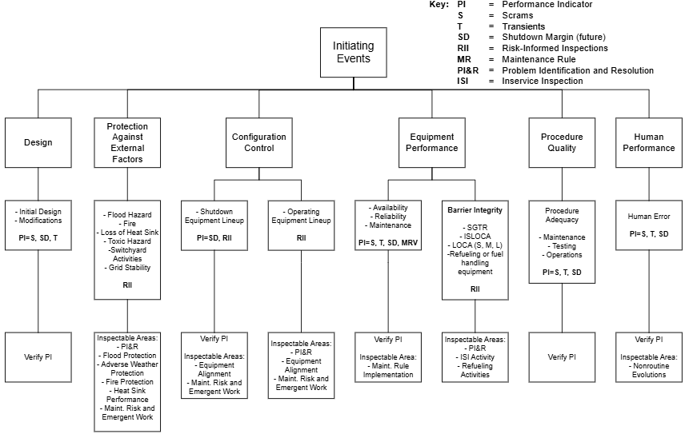
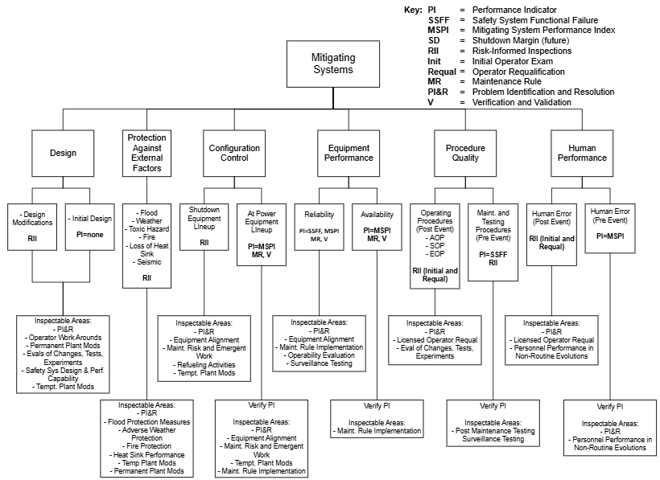
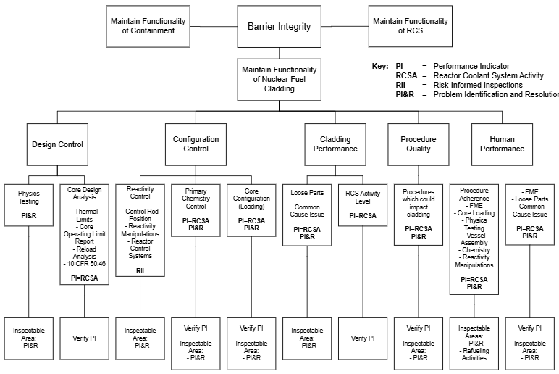
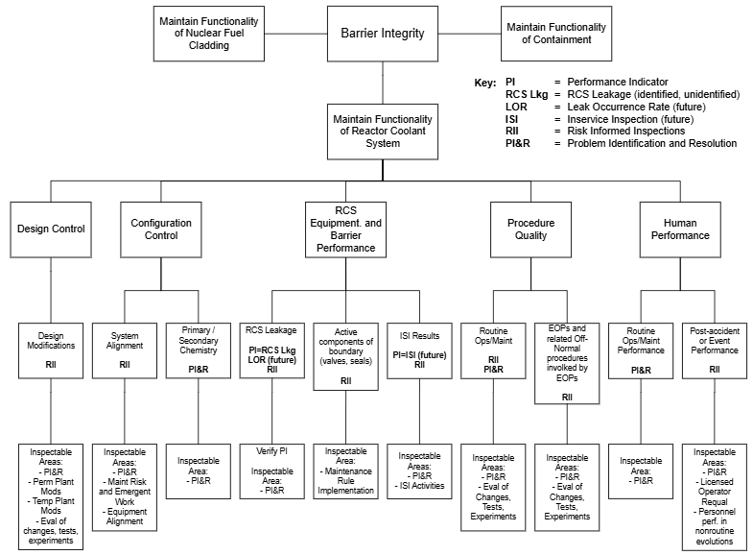
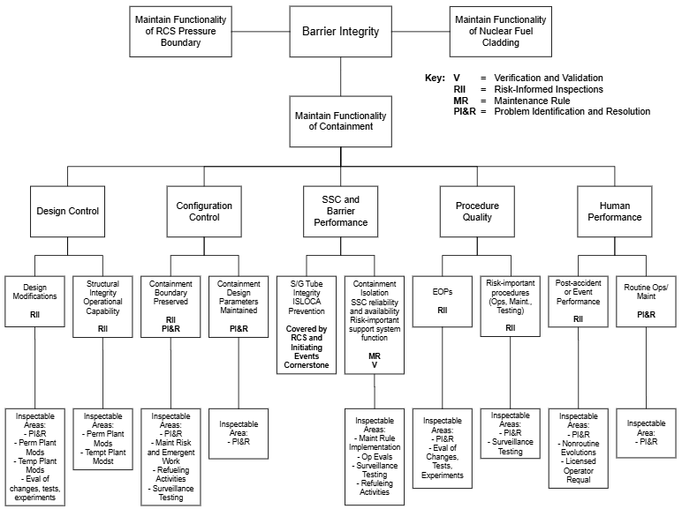
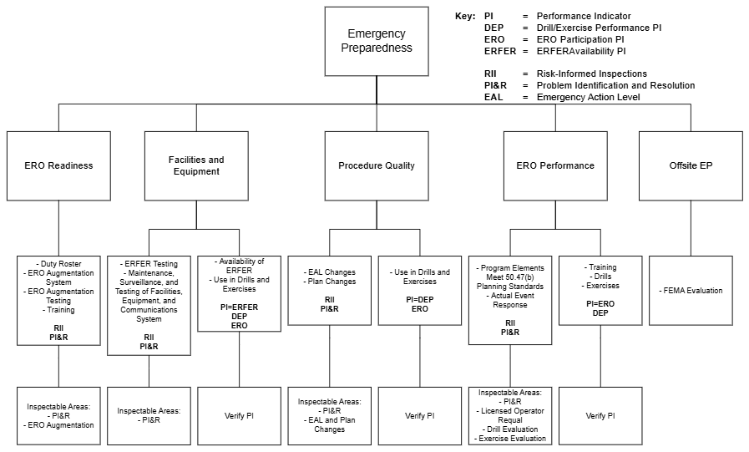
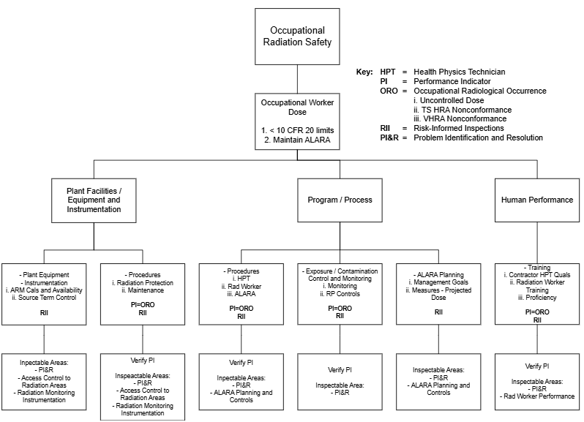
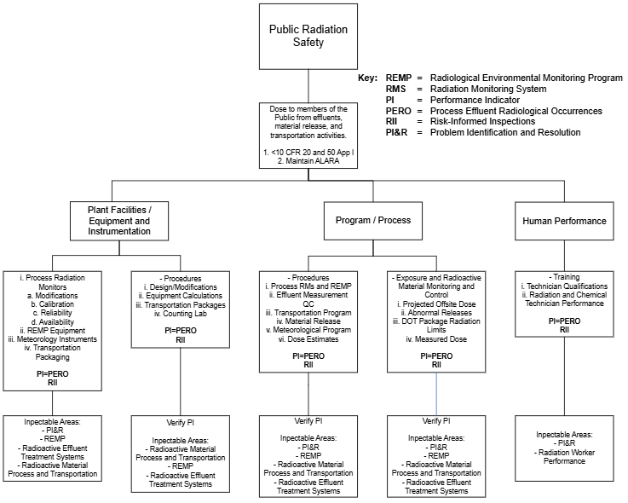
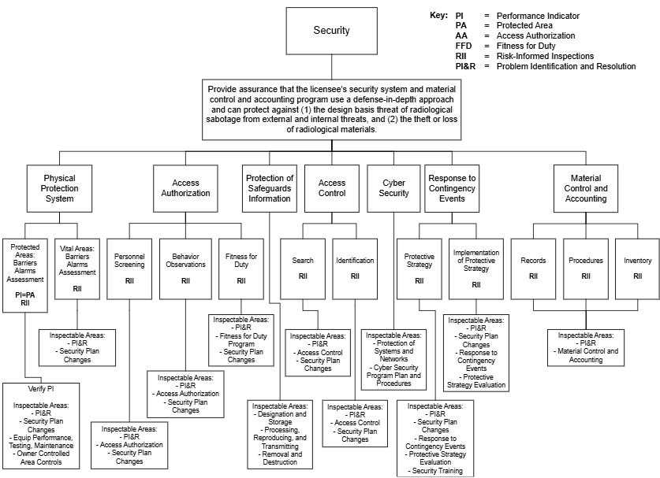

Attachment 3: BASELINE INSPECTION PROCEDURES
IP/IA No. | Title | Frequency¹
71111 Reactor Safety – Initiating Events, Mitigating Systems, Barrier Integrity
71111.01 | Adverse Weather Protection | A
 | (Reserved)
 | (Reserved)
71111.04 | Equipment Alignment | Q/A
71111.05 | Fire Protection | Q/A
71111.06 | Flood Protection Measures | A
71111.07 | Heat Exchanger/Sink Performance | A
71111.08 | Inservice Inspection Activities | R
 | (Reserved)
 | (Reserved)
71111.11 | Licensed Operator Requalification Program and Licensed Operator Performance | Q/B
71111.12 | Maintenance Effectiveness | A
71111.13 | Maintenance Risk Assessment and Emergent Work Control | A
 | (Reserved)
71111.15 | Operability Determinations and Functionality Assessments | A
 | (Reserved)
71111.18 | Plant Modifications | A
71111.20 | Refueling and Other Outage Activities | R
71111.21M | Comprehensive Engineering Team Inspection (CETI) | QD
71111.21N – Focused Engineering Inspections (FEI)
71111.21N.01 | Environmental Qualification Inspection | QD²
71111.21N.02 | Design Basis Capability of Power-Operated Valves Under 10 CFR 50.55a Requirements | QD²
71111.21N.03 | Commercial Grade Degradation | QD²
71111.21N.04 | Age-Related Degradation | QD²
71111.21N.05 | Fire Protection Team Inspection (FPTI) | QD²
71111.24 | Testing and Maintenance of Equipment Important to Risk | A
 | (Reserved)
71114 Reactor Safety – Emergency Preparedness
71114.01 | Exercise Evaluation | B
71114.02 | Alert Notification System Testing | B
71114.03 | Emergency Response Organization Staffing and Augmentation System | B
71114.04 | Emergency Action Level and Emergency Plan Changes | A
71114.05 | Maintenance of Emergency Preparedness | B
71114.06 | Drill Evaluation | A
71114.07 | Exercise Evaluation - Hostile Action (HA) Event | T
71114.08 | Exercise Evaluation – Scenario Review
71124 Radiation Safety – Public and Occupational
71124.01 | Radiological Hazard Assessment and Exposure Controls | A
71124.03 | In-Plant Airborne Radioactivity Control and Mitigation | B
71124.04 | Occupational Dose Assessment | B
71124.05 | Radiation Monitoring Instrumentation | B
71124.06 | Radioactive Gaseous and Liquid Effluent Treatment | T
71124.07 | Radiological Environmental Monitoring Program | T
71124.08 | Radioactive Solid Waste Processing and Radioactive Material Handling, Storage, and Transportation | B
71130 Security³
Other Baseline Procedures
71151 | Performance Indicator Verification | A
71152 | Problem Identification and Resolution (PI&R) | A/B
71153 | Follow up of Events and Notices of Enforcement Discretion | AN
92701 | Followup | AN

¹Q = Quarterly, A = Annual, R = Refueling Outage, B = Biennial, T = Triennial,
AN = As Needed, QD = Quadrennial

²The frequency is considered quadrennial, if selected during the cycle

³For a complete list of baseline inspection procedures associated with the security cornerstone, refer to IMC 2201 App A, “Security Baseline Inspection Program.”

Attachment 4: Revision History IMC 2515 Appendix A
Commitment Tracking Number | Accession Number  Issue Date  Change Notice | Description of Change | Description of Training Required and Completion Date | Comment Resolution and Closed Feedback Form Accession Number (Pre-Decisional, Non-Public Information)
N/A | ML020380293  1/17/02  CN 02-001 | Clarified guidance for distributing inspection effort across units at multi-unit sites and focusing efforts if no inspection samples are available. | N/A | N/A
N/A | ML061580537  01/26/07  CN 07-004 | In response to FF 2515A-946, changed regional planning requirement from 12-month look-ahead to 18 month. Deleted attachment 3 - resource estimates since each IP contains a more up-to-date resource estimate.  Completed 4 year historical change notice search. | N/A | ML063460228
N/A | ML080310086  05/01/08  CN 08-014 | Addition of Attachment 3 – Baseline Inspection Procedures | N/A | N/A
N/A | ML082110537  09/03/08  CN 08-025 | Added requirement for region-based inspectors to review all open allegations pertaining to the areas to be inspected during inspection preparation as part of regulatory improvements resulting from Peach Bottom Lessons Learned Review Team’s analysis of inattentive security officers at the Peach Bottom nuclear plant in 2007 (WITs item 200800148). | N/A | ML082410742
N/A | ML11292A135110/28/11  CN 11-023 | IP 71150 was converted into an infrequent procedure in IMC 2515 Appendix C because of the ROP realignment analysis results. | N/A | N/A
N/A | ML13032A168 03/08/13  CN 13-008 | Updated Table in Attachment 3, “Baseline Inspection Procedures”; incorporated recommendations contained in FF 2515A-1791 and -1840. | N/A | N/A
N/A | ML18180A098  07/26/19  CN 19-024 | Updated Table in Attachment 3 to allow inspectors to charge time to IP 92701 for URI closure. | N/A | ML18222A407
N/A | ML24193A117  12/12/24  CN 24-042 | Incorporated recommendations from feedback form 2515A-2479 and revised IMC to align it with changes made to baseline inspection procedures. Revised to comply with IMC 0040 formatting changes. | N/A | ML24198A245  2515A-2479  ML23089A234
N/A | ML25072A253  06/20/25  CN 25-017 | Deleted guidance for inspecting to nominal samples as a result of ADVANCE Act implementation. |  | ML25097A274

