**NRC INSPECTION MANUAL** NMSS/DFM

INSPECTION MANUAL CHAPTER 0610 APPENDIX G

SCREENING AND DOCUMENTATION OF VERY LOW SAFETY  
SIGNIFICANCE ISSUE RESOLUTION PROCESS

Effective Date: 04/11/2024

# 0610G-01 PURPOSE

Inspectors can use the Very Low Safety Significance Issue Resolution (VLSSIR) process to discontinue inspection of an issue involving an unresolved licensing basis question in which the resolution of the question cannot be resolved without considerable staff effort and the issue[1] would be of no greater than severity level (SL) IV, if determined to be a violation. In these circumstances, the agency can choose not to expend further inspection effort to resolve the question. In the context of VLSSIR, the term “licensing basis” refers to all regulations, license conditions, and requirements applicable to a facility or licensee, including, but not limited to, the licensee’s written commitments for ensuring compliance. The VLSSIR process uses the criteria below to determine if an issue would be no greater than SL IV, if determined to be a violation, without expanding additional resources to resolve the question.

The VLSSIR process cannot be used to disposition a known compliance issue or an issue where there is a clear indication that a non-compliance occurred, regardless of the significance.

# 0610G-02 OBJECTIVES

02.01 To provide the screening criteria for VLSSIR applicability.

02.02 To provide guidance related to documentation of licensing basis questions that the staff has determined to discontinue inspection.

# 0610G-03 APPLICABILITY

The VLSSIR process as described below is applicable to the Office of Nuclear Material Safety and Safeguards business lines.

# 0610G-04 DEFINITIONS

VLSSIR Process: A process used to discontinue inspection of an issue involving an unresolved licensing basis question in which: (1) the resolution of the issue would require considerable staff effort; and (2) the agency has chosen to not expend further effort to resolve the question because the issue would be no greater than SL IV, if determined to be a violation.

# 0610G-05 RESPONSIBILITIES AND AUTHORITIES

1. Inspector’s supervisor may work with the inspector to determine if additional inspection to resolve the unresolved licensing basis question is warranted consistent with the VLSSIR screening process.
2. Inspector has ability to use VLSSIR process to discontinue inspection of an issue involving an unresolved licensing basis question.
3. The management team and inspection staff have a shared responsibility to continually balance the resources applied to an inspection activity relative to the potential safety significance of the activity to ensure inspection resources are prioritized commensurate with the issue’s safety significance. The VLSSIR process should be considered as a tool to help achieve an appropriate balance.

# 0610G-06 REQUIREMENTS

There are no new requirements introduced within this IMC.

# 0610G-07 GUIDANCE

In some cases, an inspector may identify an issue involving an unresolved licensing basis question. In these cases, the inspector should consider the significance of the concern using the screening criteria provided in figure 1.

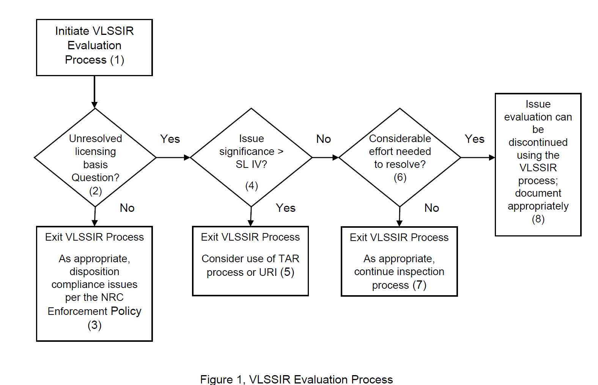

PROCESS: STEPS – See figure 1

To determine whether further evaluation of an issue can be discontinued using the VLSSIR process, the following steps should be followed:

Block (1) Initiate VLSSIR Evaluation Process: The VLSSIR process provides an option for discontinuing the evaluation of certain unresolved licensing basis questions when (a) considerable effort would be required to resolve the issue, and (b) the issue would align with those that would be no greater than SL IV, if determined to be a violation. In the context of VLSSIR, the term “licensing basis” refers to all regulations, license conditions, and requirements applicable to a facility or licensee, including, but not limited to, the licensee’s written commitments for ensuring compliance. The use of the VLSSIR process is expected to be rare as the NRC is generally expected to have clarity in licensing bases. Use of VLSSIR is not mandatory but is an option for inspectors to consider in determining whether to discontinue inspection of an item. The inspector should make the licensee aware of the issue and staff’s consideration of the VLSSIR process. If the licensee can provide additional information that can resolve the concern (e.g., provide information that shows the concern is not a regulatory compliance issue), no further inspection effort may be necessary.

Block (2) Determine if an unresolved licensing basis question exists: Before concluding that an unresolved licensing basis question exists, an appropriate level of inspection effort should be expended to resolve the issue (e.g., consideration should be given to the resources assigned for the inspection activity and the time expended on the inspection to exercise due diligence in attempting to resolve the issue). If an inspector is unsure of the appropriate level of effort to expend in attempting to resolve the licensing basis question, they should consult with management. Together they should weigh the issue characterization, available licensing basis information, and risk insights to determine if additional inspection and evaluation to resolve the unresolved licensing basis question is warranted. In addition, the inspector should consider any licensee provided supporting information related to the issue of concern and the associated regulatory basis. If, after expending a reasonable inspection effort, it is determined that an unresolved licensing basis question exists, the safety significance of the issue is evaluated under block (4). Issues where the licensing basis question is clear should be dispositioned outside the VLSSIR process (see block (3)). For issues where there is a clear indication that a noncompliance occurred but certain details concerning the issue have not been finalized (e.g., specific date, time, location), use of the VLSSIR process is not appropriate. In this case, the inspector should evaluate if additional inspection is warranted using normal inspection guidance to disposition any compliance issue using the NRC Enforcement Policy.

Block (3) Exit the VLSSIR process if there is not an unresolved licensing basis question: If the licensing basis question is resolved (either by determining that a violation exists, that there is clear indication that a non-compliance occurred, or that the issue is not associated with a regulatory requirement), the inspector should exit the VLSSIR process and appropriately disposition the issue. Compliance issues shall be dispositioned consistent with the NRC Enforcement Policy.

Block (4) Determine if the issue is greater than SL IV: The issue of concern should be of no greater than SL IV to use the VLSSIR process. In analyzing whether an issue falls within this threshold, the inspector should consider whether the issue, if it were determined to be a compliance issue, would not have the potential to be of greater severity than SL IV violation examples as described in the NRC Enforcement Policy for the associated activity area. Staff should consult with management, in determining whether it may be appropriate to continue to expend efforts to resolve an issue that otherwise satisfies the VLSSIR screening criteria based on the unique circumstances of the issue.

VLSSIR should not be applied to the import and export and discrimination activity areas, even when the issue is of no greater than SL IV.

Block (5) Exit the VLSSIR process if the issue is greater than SL IV: If safety significance of the unresolved licensing basis question is greater than SL IV, the VLSSIR process cannot be used. Consideration should be given to use of the Unresolved Item (URI) and/or Technical Assistance Request (TAR) processes to resolve the licensing basis question.

Block (6) Determine if considerable effort is required to resolve licensing basis question: The objective of this step is to assess the effort required to resolve an issue that is no greater than SL IV, and whether resolution of the issue would effectively and efficiently serve the agency’s mission. When assessing this criterion, consideration should be given to the time already expended on the inspection, the estimated effort and resources needed to resolve the licensing basis question, and the uncertainties associated with the issue. In assessing if the additional resources needed to resolve the issue would be “considerable,” the inspector should consult with management. Together they should weigh the issue characterization to determine if resolution of an issue that is not greater than SL IV is an effective and efficient use of agency resources.

Block (7) Exit the VLSSIR process if considerable effort is not needed to resolve the issue: In this case, the inspector should continue the inspection to resolve the issue. If a reasonable amount of additional inspection effort does not resolve the issue, the level of effort needed to resolve the issue can be reassessed and the block (6) revisited.

Block (8) Discontinue inspection and evaluation of the issue using the VLSSIR process and document appropriately: If the staff determines that the issue is appropriate for the VLSSIR process and meets the screening process, inspection effort on the issue can be discontinued. When the VLSSIR process is used to terminate further inspection on an unresolved licensing basis question, the staff should refrain from spending additional inspection resources on the issue. All issues dispositioned using the VLSSIR process should be documented in the inspection report or equivalent document. Documentation of VLSSIR issue closure provides several benefits, including the following:

* Documentation provides the bases for discontinuing inspection/evaluation and when applicable, the closure basis for a previously documented unresolved issue/item (e.g., a URI).
* Documentation would alert future inspectors/licensee to the existence of the unresolved licensing basis question and avoid re-inspection of the issue without new information.
* Documentation provides transparency with external stakeholders on the use of the VLSSIR process.

However, documenting the discontinuation of issue evaluation using the VLSSIR process should not create a staff position (e.g., the forward fit or backfit outside of the appropriate processes). In fact, the staff is making a deliberate decision not to expend additional agency resources to make a determination on the unresolved question. It should be noted that VLSSIR issues documented in inspection reports should never indicate that the licensee is in compliance or that their actions are acceptable, but rather the reports should state that inspectors made a determination that the VLSSIR process was appropriate, so the agency made a decision to discontinue inspection efforts to evaluate the issue.

If the evaluation of any unresolved licensing basis question is discontinued using the VLSSIR process, documentation of this decision is provided within the inspection report in the Observations and Violations or equivalent section. The level of documentation should provide a knowledgeable and informed reader with an appropriate understanding of the issue, explain the basis for discontinuing further inspection effort on the issue, support knowledge management and provide transparency. It is expected that most VLSSIR issues could be appropriately documented with no more than several paragraphs and generally less than the level of documentation normally associated with similar significance issues (e.g., SL IV enforcement issue).

The following information should be used to describe the issue:

* A brief description of the circumstances associated with the issue and any relevant information on the licensing basis question developed during the inspection process.
* A brief description of the significance of the issue in terms of the VLSSIR screening criteria.
* Any licensee provided information related to the licensing basis question.
* A reference to a URI and/or TAR, if applicable.
* If the issue was considered using NMSS Policy and Procedure 7-05, “NMSS Processing of Technical Assistance Requests,” or NRR’s COM-106, “Technical Assistance Request (TAR) Process,” briefly summarize how the results of that process led to the issue being documented in accordance with the VLSSIR process.

The discontinuation of issue evaluation using the VLSSIR process should conclude with the following sentences.

“This issue is an unresolved licensing basis question which is determined to be no greater than SL IV. Inspection and evaluation effort is being discontinued using the Very Low Safety Significance Issue Resolution (VLSSIR) process. No further staff evaluation is required.”

# 0610G-08 REFERENCES

1. “NRC Enforcement Policy,” (https://www.nrc.gov/about-nrc/regulatory/enforcement/enforce-pol.html)

2. NMSS Policy and Procedure 70-09, “Procedures for Processing of Technical Assistance Requests” (formally P&P 7-05) (internal document)

3. NRR Office Instruction COM-106, “Technical Assistance Request (TAR) Process” (internal document)

END

Attachment 1: Revision History for IMC 0610 Appendix G

|  |  |  |  |  |
| --- | --- | --- | --- | --- |
| Commitment Tracking Number | Accession Number  Issue Date  Change Notice | Description of Change | Description of Training Required and Completion Date | Comment Resolution and Closed Feedback Form Accession Number  (Pre-Decisional Non-Public Information) |
|  | ML23291A357 04/23/24  CN 24-013 | Initial issuance of the appendix to formalize interim staff guidance for NMSS implementation of the Very Low Safety Significance Issue Resolution Process. See Memo from John W. Lubinski, “Office of Nuclear Material Safety and Safeguards Implementation of Very Low Safety Significance Issue Resolution Process,” dated July 3, 2023 (ADAMS Accession No. ML22353A596). | None. |  |

1. Although the definition for VLSSIR refers to "safety significance," the VLSSIR process applies to a broad range of regulated areas related to safety, including security, emergency planning and preparedness, documentation control, and reporting.