**NRC INSPECTION MANUAL** APOB

INSPECTION MANUAL CHAPTER 0609 APPENDIX G

SHUTDOWN OPERATIONS

SIGNIFICANCE DETERMINATION PROCESS

Effective Date: 03/01/2020

TABLE OF CONTENTS

0609G-01 PURPOSE 1

0609G-02 OBJECTIVES 1

0609G-03 DEFINITIONS 2

0609G-04 GUIDANCE 6

0609G-05 REFERENCES 8

Figure 1: Road Map for Shutdown Findings………………………………………………….... 9

Attachment 1: Revision History Table………………………………………………....….….… Att1-1

# 0609G-01 PURPOSE

Appendix G provides guidance for Phases 1 and 2 of the Significance Determination Process (SDP) for shutdown operations. The SDP Phase 1 guidance, presented as Attachment 1 to Appendix G, is a separate document in the manual chapter and consists of screening criteria developed specifically for shutdown operations. When inspectors identify findings that affect shutdown conditions, they will use the Phase 1 guidance for both pressurized water reactors (PWRs) and boiling water reactors (BWRs). Attachment 1 lists the criteria for types of findings that would require further evaluation by Phase 2 or 3 of the SDP. After the inspector determines that a Phase 2 or 3 analysis is needed, he or she will transition the evaluation to a Senior Reactor Analyst (SRA) for further review. The guidance for Phase 2 is presented in Appendix G as Attachments 2 and 3. Attachment 2 provides Phase 2 guidance for PWRs and Attachment 3 provides Phase 2 guidance for BWRs. These attachments are generic in nature for both reactor types. Phase 3, detailed risk evaluation, analyses are referred directly to Headquarters staff to be performed. The road map for shutdown inspection findings through SDP Phases 1 and 2 is shown in Figure 1.

# 0609G-02 OBJECTIVES

Shutdown operations in both PWRs and BWRs introduce a different spectrum of vulnerabilities that may not be applicable during at-power operations. A shutdown plant is in a safe condition as long as certain key safety functions are maintained and managed adequately. Those functions are:

* decay heat removal
* inventory control
* power availability
* reactivity control, and
* containment closure capability

Analysis of shutdown events has provided a better understanding of these vulnerabilities and has informed the development of this SDP.

It is important to note that the scope of activities that each utility undertakes during a normal refueling outage is large and diverse. Besides refueling, activities associated with preventive and corrective maintenance, modifications, surveillance testing, in-service inspection, and the administrative activities that support these tasks make outage planning and control a significant challenge. The coordination of these activities, with the objective to manage risk and maintain key safety functions, is essential and goes beyond compliance with technical specifications requirements during shutdown. In addition, while the scope of activities for an unplanned or forced outage is far less than that of a refueling outage, the same awareness of vulnerabilities during shutdown conditions is required to safely conduct these outages. This SDP has been developed to assist the agency in determining the safety significance of findings during shutdown conditions taking into account the unique characteristics described above.

# 0609G-03 DEFINITIONS

03.01 ABBREVIATIONS

|  |  |
| --- | --- |
| AC | Alternating Current |
| BI | Barrier Integrity |
| BWR | Boiling Water Reactor |
| CCDP | Conditional Core Damage Probability |
| CCW | Component Cooling Water |
| CD | Core Damage |
| CDF | Core Damage Frequency |
| CETs | Core Exit Thermocouples |
| CST | Condensate Storage Tank |
| DC | Direct Current |
| DHR | Decay Heat Removal |
| ECCS | Emergency Core Cooling System |
| ICCDP | Incremental Conditional Core Damage Probability |
| IE | Initiating Event |
| IEL | Initiating Event Likelihood |
| IMC | Inspection Manual Chapter |
| INDIC | Indication |
| LOI | Loss of Reactor Inventory Initiating Event |
| LOLC | Loss of Level Control |
| LOOP | Loss of Offsite Power |
| LORHR | Loss of RHR Initiating Event |
| LOSDC | Loss of Shutdown Cooling |
| LTOP | Low Temperature Over-Pressurization |
| MS | Mitigation Systems |
| OD | Over Drain |
| OP | Operator |
| OPDRV | Operation with Potential to Drain Reactor Vessel |
| PORV | Power Operated Relief Valve |
| POS | Plant Operational State |
| PRA | Probabilistic Risk Assessment |
| PTS | Pressurized Thermal Shock |
| PWR | Pressurized Water Reactor |
| RCS | Reactor Coolant System |
| RHR | Residual Heat Removal |
| RHRSW | Residual Heat Removal Service Water |
| ROP | Reactor Oversight Process |
| RV | Relief Valve |
| RWST | Refueling Water Storage Tank |
| SD | Shutdown |
| SDC | Shutdown Cooling |
| SDP | Significance Determination Process |
| SG | Steam Generator |
| SG PORV | Steam Generator Power Operated Relief Valve |
| SRA | Senior Reactor Analyst |
| TTB | Time to Boiling |
| TW | Time Window |
| TW-E | Early Time Window, before refueling operation |
| TW-L | Late Time Window, after refueling operation |

03.02 DEFINITIONS

The following definitions apply to both PWRs and BWRs, unless otherwise specified.

Available - A piece of equipment is considered available if (1) it can be put into service within half the time that is needed before the equipment will be used to perform its function, (2) procedures or standing orders exist for using the equipment to meet its intended function, (3) all necessary supporting systems (such as AC power, cooling water, and DC control power) can be put into service within half the time that is needed before the equipment will be used to perform its function, and (4) operators have been trained on using the equipment for the given situation.

Cavity Flooded - An RCS condition with the reactor head removed and the water level raised to the refuel floor.

Core Damage - Core damage corresponds to a peak clad temperature above 1300 degrees Fahrenheit. Above 1340 degrees Fahrenheit, phenomena such as clad oxidation and ballooning affect core behavior. This definition is consistent with the definition of the onset of core damage used in NUREG/CR 6144 Vol. 2, Part 1A, "Evaluation of Potential Severe Accidents During Low Power and Shutdown Operations at Surry, Unit 1, Analysis of Core Damage Frequency from Internal Events During Mid‑Loop Operations."

Gravity Feed (PWR Only) - Gravity feeding is the process of adding water to the RCS from a storage source (e.g., condensate storage tank or refuel storage tank) without an active component (e.g., pump). It requires the water source to be higher than the reactor and the reactor to be at or capable of reaching atmospheric pressure. Gravity feeding may be credited if gravity feed is expected to be available AFTER RCS boiling initiates. To credit gravity feed, the analyst needs to consider the following factors that can negate the elevation head provided by the RWST or other sources of RCS inventory: (1) pressure drops in the surge line, (2) entrained water accumulating in the pressurizer, (3) RCS vent paths that are restricted (to control loose parts or control off gassing).

Mid-loop Operation (PWR Only) - Mid-loop conditions exist whenever the RCS water level is below the top of the flow area of the hot legs at the junction with the reactor vessel.

Operation with Potential to Drain Reactor Vessel - A planned maintenance evolution that if it is not conducted properly can lead to a loss of inventory event. Therefore, any issues with operations with potential to drain the reactor vessel should be evaluated using the appropriate LOI criteria.

Reduced Inventory Operation - An RCS inventory condition that results in a reactor vessel water level lower than three feet below the reactor vessel flange. Mid-loop is a subset of reduced inventory. Also, one or more fuel assemblies must be in the reactor vessel. PWR only.

RCS Vented - For PWR plants, the RCS is considered vented when (1) SG heat removal cannot be sustained, and (2) a vent path has been established that is large enough to support feed and bleed. Examples of vent paths include: open pressurizer manways, safety relief valve removal, or vessel head removal. For BWR plants, the RCS is considered vented when (1) the vessel head is removed OR (2) the vessel head is on, however, a sufficient RCS vent path exists for decay heat removal.

RWST/CST Depletion - Occurs when RWST/CST level reaches the level that requires makeup or recirculation to continue injection to the RCS.

Self-Limiting LOI - These are loss of inventory events where the leakage point is above the location where the RHR system attaches to the RCS. Therefore, the leakage will stop without human intervention before the RHR/SDC system is lost. For these types of LOIs there shall be no reliance on manual or automatic actions.

Shutdown Operation - Shutdown operation exists during refueling outages, forced outages, and maintenance outages starting when the plant has met the entry conditions for RHR/DHR and cooling has been initiated, and ending when the plant is heating up and RHR/DHR has been secured.

Phases of a Significance Determination

Phase 1 - Characterization and Initial Screening of Findings: Phase 1 is used to characterize the important attributes of the inspection finding and to initially screen the finding to identify those with very low significance (Green), or greater than very low safety significance. Findings screened to be of very low significance can be dispositioned by the licensee’s corrective action program.

Phase 2 - Initial Risk Significance Approximation and Basis: Initial approximation of the risk significance of the finding and development of the basis for this determination for those findings that are not screened out in Phase 1 screening.

Phase 3 - Risk Significance Finalization and Justification: Also known as a detailed risk evaluation, this is a review and as-needed refinement of the risk significance estimation results from Phase 2, or development of any risk analysis outside of this guidance, by an NRC risk analyst (any departure from the guidance provided in this document or IMC 0609, Appendix G for Phase 1 or Phase 2 constitutes a Phase 3 analysis and must be performed by an NRC risk analyst).

Types of Shutdown Findings

Precursor Finding - Inspection findings that: (1) cause an event (e.g., a loss of the operating train of RHR/DHR) or (2) increase the likelihood of an event.

Condition Finding - Inspection findings that involve a degradation of the licensee’s capability to mitigate an event if an event were to occur. Findings affecting the standby train of RHR/DHR are condition findings.

Shutdown Initiating Events

Loss of RHR (LORHR) - Includes losses of RHR/DHR resulting from failures of the RHR/DHR system (such as a RHR/DHR pump failure) or failures of the RHR/DHR support systems other than offsite power.

Loss of Offsite Power (LOOP) - Includes losses of offsite power which cause a loss of the RHR/DHR function.

Loss of Reactor Inventory (LOI) - Includes losses of RCS inventory that cause, or could cause, a loss of the RHR/DHR function due to automatic isolation of RHR/DHR on low level for BWRs or loss of RHR/DHR pump suction.

Loss of Level Control (LOLC) - This initiating event category includes: (1) the operator overdrains the RCS to reach mid-loop conditions such that RHR/DHR is lost, and (2) the operator fails to maintain level or flow control while in mid-loop such that the RHR/DHR function is lost. (PWR Only)

Overdrain (OD) – Overdrain is a subset of LOLC. It is intended to capture those events where while the RCS is being drained, from one target level range to a second lower range, the evolution is not stopped within the desired final range. For example, starting level is one foot below the reactor flange and the target range is six to twelve inches above the top of the hotleg. If the drain down evolution was not stopped until level reached the top of the hotleg, then an overdrain event has occurred.

PWR Plant Operational States (POSs)

POS 1 - This POS starts when the RHR/DHR system is put into service. The RCS is closed such that a steam generator(s) could be used for decay heat removal, if the secondary side of each available steam generator(s) has sufficient inventory to be considered available as a heat sink. The RCS may have a bubble in the pressurizer. This POS ends when the RCS is vented such that the steam generators cannot sustain core heat removal. This POS typically includes Mode 4 (hot shutdown) and portions of Mode 5 (cold shutdown).

POS 2 - This POS starts when the RCS is vented such that: (1) the steam generators cannot sustain core heat removal and (2) a sufficient vent path exists for feed and bleed. This POS includes portions of Mode 5 (cold shutdown) and Mode 6 (refueling). Reduced inventory operations and mid-loop operations with a vented RCS are subsets of this POS.

NOTE: Findings occurring during vacuum refill of the RCS require use of the POS 1 event trees

POS 3 - This POS represents the shutdown condition when the refueling cavity water level is at or above the minimum level required for movement of irradiated fuel assemblies within containment as defined by Technical Specifications. This POS occurs during Mode 6.

BWR Plant Operational States (POSs)

POS 1 - This POS starts when the RHR/DHR system is put into service. The vessel head is on and the RCS is closed such that an extended loss of the RHR/DHR function without operator intervention could result in an RCS re-pressurization above the shutoff head for the RHR/DHR pumps.

POS 2 - This POS represents the shutdown condition when (1) the vessel head is removed and reactor pressure vessel water level is less than the minimum level required for movement of irradiated fuel assemblies within the reactor pressure vessel as defined by Technical Specifications OR (2) the vessel head is on, however, a sufficient RCS vent path exists for decay heat removal.

POS 3 - This POS represents the shutdown condition when the reactor pressure vessel water level is equal or greater than the minimum level required for movement of irradiated fuel assemblies within the reactor pressure vessel as defined by Technical Specifications. This POS occurs during Mode 5 (refueling).

Time Windows

Early Time Window (TW-E) - This time window represents the time before POS 3 is entered. The decay heat is relatively high. The reactor is either in POS 1 or 2.

Late Time Window (TW-L) - This time window represents the time after POS 3 is entered. The decay heat is relatively low.

# 0609G-04 GUIDANCE

04.01 SCOPE

Appendix G is applicable during refueling outages, forced outages, and maintenance outages starting when the plant has met the entry conditions for RHR/DHR and cooling has been initiated, and ending when the plant is heating up and RHR/DHR has been secured.

Note: If the licensee is in a refueling outage or forced outage and the plant is above RHR/DHR entry conditions, then inspectors will use the full power SDP tools acknowledging: (1) decay heat is less compared to full power, potentially allowing for more time for operator recovery, (2) some mitigating systems may require manual operation versus automatic operation, and (3) some containment systems may not be required to be operable potentially increasing the likelihood of containment failure.

If the plant is shutdown and the entry conditions for RHR/DHR and RHR/DHR cooling have not been met, then Appendix G does not apply. The inspectors shall contact the SRA for assistance. Appendix G is used to evaluate two categories of findings: those that actually cause an event or increase the likelihood of an event (i.e., precursor findings), and those that affect the ability to mitigate an event (i.e., condition findings).

Typical events of interest are: losses of RHR/DHR, losses of RCS inventory, low temperature over pressurization (LTOP) events, and reactivity events. Another category of events is losses of level control, which are discussed in Section 4.3. Losses of RHR/DHR include (but may not be limited to) those caused by RHR/DHR system isolation, LOOP, failure of the running pump, failure of cooling to the respective RHR/DHR heat exchanger, failure of system flow (e.g., flow divergence away from the RCS), etc. Losses of inventory may or may not progress to the point of losing RHR/DHR. Regardless, all losses of inventory should receive an appropriate review.

Appendix G is used to screen shutdown findings for risk significance. When using this guidance to assess a finding, there are two possible outcomes: (1) the finding requires quantitative assessment (Phase 2 or Phase 3 analysis) to determine its risk significance, or (2) the finding can be screened as having very low risk significance (Green). The road map for shutdown inspection findings for SDP Phases 1 and 2 is shown in Figure 1.

04.02 MITIGATION CAPACITY

Attachment 1 of this appendix contains screening questions in Exhibits 2-5 for shutdown operation to ensure that the licensee is maintaining adequate mitigation capability. The screening questions were developed to encompass all plant operational states defined by: operational mode, time to boiling, reactor coolant system level, and reactor coolant system configuration. To complete Exhibits 2-5 the inspector will need to use Table G1 in Exhibit 1 of Attachment 1. In Table G1, there is a set of equipment, systems, instrumentation, policies, and procedures that the staff expects the licensee to maintain during shutdown. Table G1 is grouped by the five shutdown safety functions identified by NUMARC 91-06: decay heat removal, inventory control, power availability, reactivity control, and containment. The inspector should check to ensure that each applicable screening question in Exhibits 2-5 is being met. If the applicable screening questions are not being met, then follow the direction in the exhibits for either a Phase 2 or Phase 3 quantitative assessment. Findings not requiring quantitative assessment may be screened as Green.

04.03 LOSSES OF LEVEL CONTROL DURING SHUTDOWN

In addition to ensuring that the licensee minimizes events and maintains mitigation capability during shutdown, the staff is also monitoring conditions or events that represent a loss of level control. If the conditions, as described in Attachment 1 of this appendix occur, then the finding needs to be quantitatively assessed. Losses of level control only apply to PWRs.

04.04 FINDINGS REQUIRING QUANTITATIVE ASSESSMENT

If a finding needs quantitative assessment, then the finding should be forwarded to the SRA. The SRA will then decide if the finding should be forwarded to NRR for Phase 3 analysis or the finding will be evaluated using the Phase 2 PWR and BWR templates located in Attachments 2 and 3, respectively. The SRA should be sent the completed Phase 1 evaluation associated with the finding and a complete description of the finding.

# 0609G-05 REFERENCES

SECY-97-168, “Issuance for Public Comment of Proposed Rulemaking Package for Shutdown and Fuel Storage Pool Operation.”

NUMARC 91-06, “Guidelines for Industry Actions to Assess Shutdown Management.”

Generic Letter (GL) 88-17, “Loss of Decay Heat Removal – 10 CFR 50.54(f).”

Federal Register (dated February 4, 1999, Vol. 64, no. 23)

IMC 0308, Attachment 3, Appendix G, “Technical Basis for Shutdown Operations Significance Determination Process.”

Information Notice (IN) 88-36, “Possible Sudden Loss of RCS Inventory During Low Coolant Level Operation.”

EPRI NSAC-164L, “Guidelines for BWR Reactivity Control during Refueling,” 1992.

EPRI NSAC-183, “Risk of PWR Inadvertent Criticality during Shutdown and Refueling,” 1992.

EPRI 1003113 “An Analysis of Loss of Decay Heat Removal Trends and Initiation Event Frequencies, (1989-2000),” 2001.

EPRI 1003465, “Low Power and Shutdown Risk Assessment Benchmarking Study,” 2002.

EPRI 1021176, “An Analysis of Loss of Decay Heat Removal and Loss of Inventory Event Trends (1990–2009),” 2010.

NUREG/CR-5820, “Consequences of the Loss of Residual Heat Removal Systems in Pressurized Water Reactors,” 1992.

NUREG/CR-6143, “Evaluation of Potential Severe Accidents during Low Power and Shutdown Operations at Grand Gulf, Unit 1.” 1994

NUREG/CR-6144, “Evaluation of Potential Severe Accidents during Low Power and Shutdown Operations at Surry, Unit 1.” 1994.

Figure 1: Road Map for Shutdown Findings

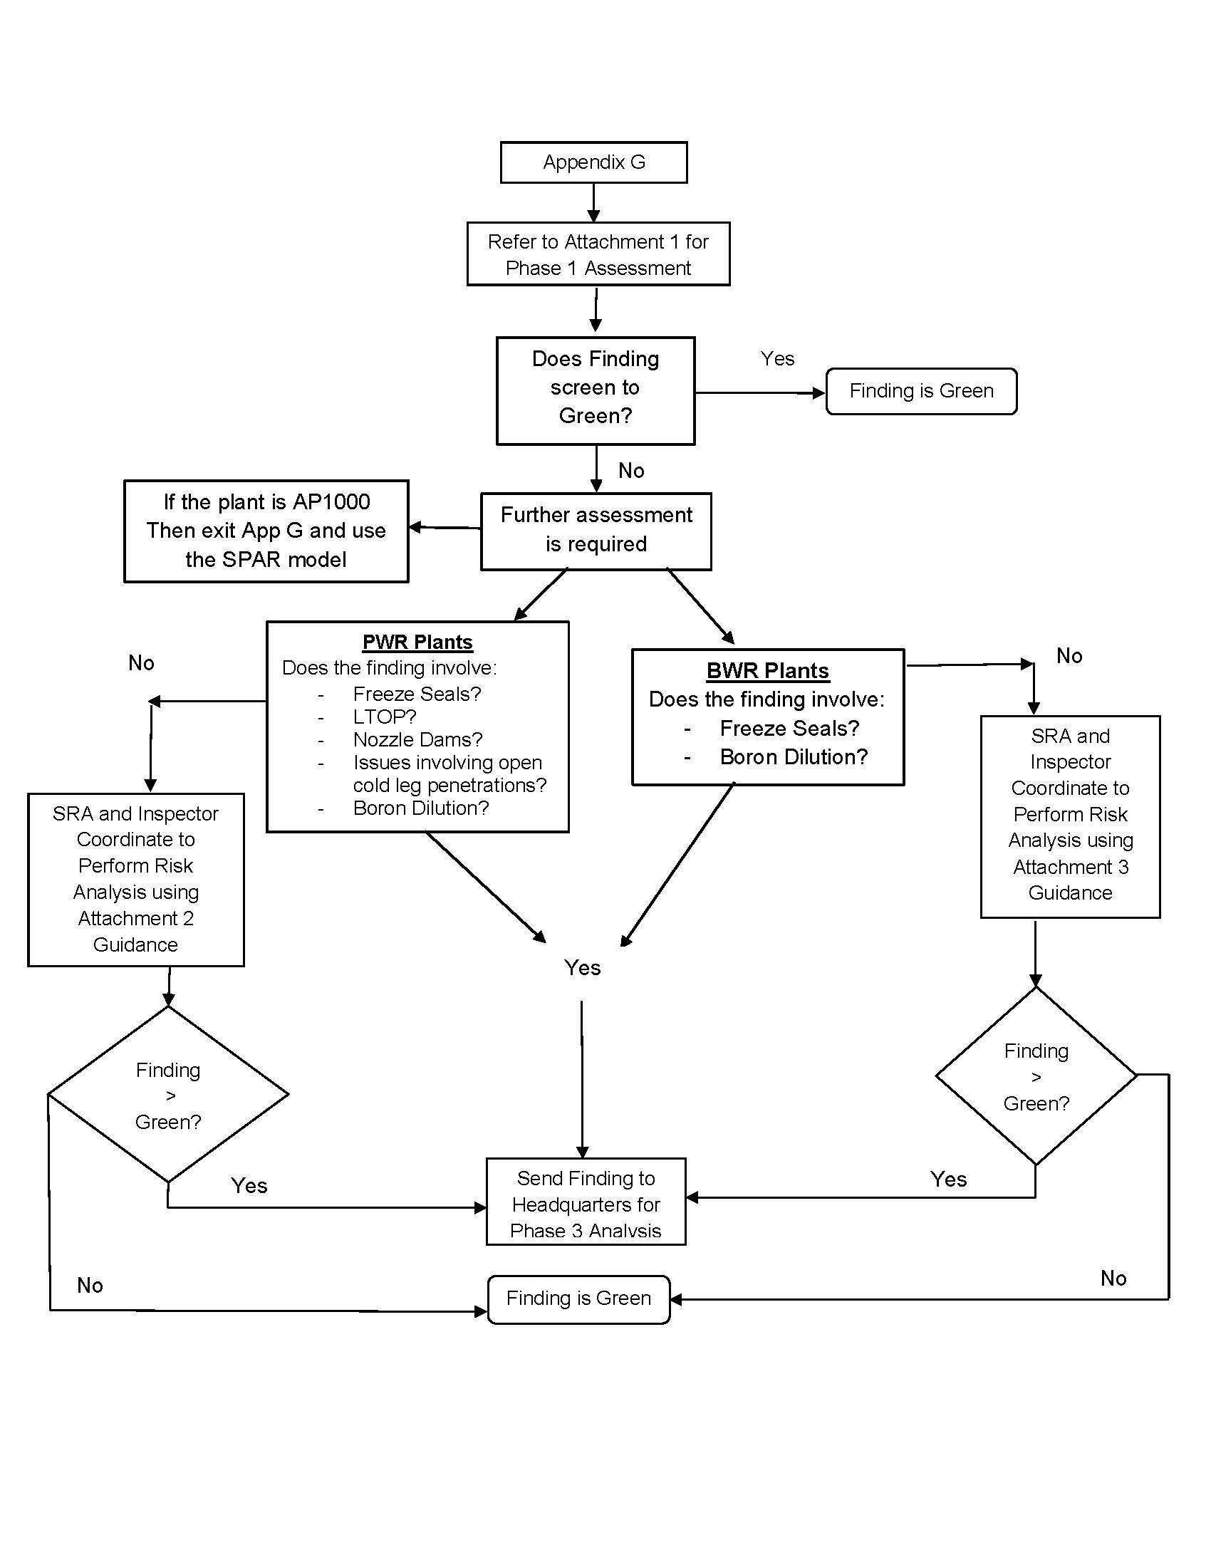

Attachment 1: Revision History Page

|  |  |  |  |  |
| --- | --- | --- | --- | --- |
| Commitment  Tracking  Number | Accession  Number  Issue Date  Change Notice | Description of Change | Description of  Training Required  And Completion Date | Comment Resolution and Closed Feedback Form Accession Number (Pre-Decisional, Non-Public Information) |
| N/A | 04/21/00  CN 00-007 | IMC 609 supports the new Reactor Oversight Program for the significance determination of findings. The significance determination process detailed in the manual chapter is designed to characterize the significance of inspection findings for the NRC licensee performance assessment process using appropriate risk insights. | N/A | N/A |
| N/A | 02/27/01  CN 01-005 | IMC 0609 App G has been revised to reflect changes based on comments by regional inspectors. These include definition for entry conditions and instructions to bring issues to the attention of the SRAs. | N/A | N/A |
| N/A | 05/25/04  CN 04-015 | IMC 0609 App G is revised to move the Phase 1 operational checklist that were previously in the main body of Appendix G and place it in a new manual chapter document. The new document is Attachment 1 to Appendix G. The separation was done to make Appendix G consistent with other SDP appendices in the manual chapter. The main body of Appendix G was changed to provide a “road map” of how to navigate through the various attachments to Appendix G. Attachments 2 and 3, which provide SDP Phase 2 guidance for PWRs and BWRs, respectively, are referenced in the revised Appendix G. | N/A | N/A |

|  |  |  |  |  |
| --- | --- | --- | --- | --- |
| Commitment  Tracking  Number | Accession  Number  Issue Date  Change Notice | Description of Change | Description of  Training Required  And Completion Date | Comment Resolution and Closed Feedback Form Accession Number (Pre-Decisional, Non-Public Information) |
| N/A | 02/28/05  CN 05-007 | IMC 609 App G is revised to clarify the definition of available. The revised definition states that necessary support systems can be put into service within half the time needed for the equipment to perform its function. | N/A | N/A |
| N/A | ML13050A933  05/09/14  CN 14-011 | IMC 0609 App G is revised to enhance the usability of this appendix, based on feedback received from the SRA. The formatting was updated to be consistent with IMC 0609 Appendix A. The abbreviations section is a new addition and the definitions section is updated to include many additional useful terms. Figure 1 is updated to be consistent with the revisions to 0609 Appendix G, Att. 1. Table 1 was removed and the information is included in Attachment 1. Incorporated feedback from ROPFF 0609G-1323 and 0609G-1932. This is a complete reissue no red line. | N/A | ML13162A640  0609G-1323  ML14120A177  0609G-1932  ML14120A169 |
| N/A | ML19101A289  01/08/20  CN 20-004 | Clarified loss of control is loss of level control and only applies to PWR plants.  Revised the definition for Shutdown Operations to align it with the scope of Appendix G.  Updated Figure 1 to clarify when analyses get sent to headquarters for review. The updated Figure 1 now includes guidance on issues with open cold leg penetrations. | No training is required. | ML19156A183 |

|  |  |  |  |  |
| --- | --- | --- | --- | --- |
| Commitment  Tracking  Number | Accession  Number  Issue Date  Change Notice | Description of Change | Description of  Training Required  And Completion Date | Comment Resolution and Closed Feedback Form Accession Number (Pre-Decisional, Non-Public Information) |
|  |  | Added additional detail to the RCS Vented definition to cover BWRs – taken from the POS 2 definition for BWRs.  Removed the statement that LOOP findings are not assessed in POS 3 since Attachment 1 still assess them depending on timing of offsite power recovery.    Eliminated the Caution prior to section 04.02, it was not necessary.  Revised the definition of “available” to make it clear that equipment can be considered available if it can be put in service within half the time before it will be needed. Not to be confused with the PRA mission time. This is also not the same “available” definition as used for maintenance rule purposes. |  |  |