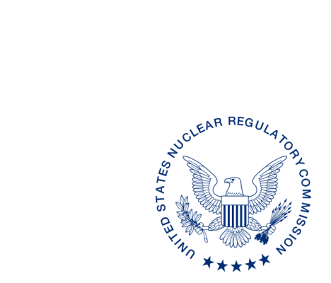
UNITED STATES
NUCLEAR REGULATORY COMMISSION
WASHINGTON, D.C. 20555-0001

{{date:long}}

[Name, Title]
[Address]

Dear [Name]:

We have reviewed the proposed revisions to the [State] regulations [State Regulation Sections], received by our office on [Date]. These regulations were reviewed by comparison to the equivalent U.S. Nuclear Regulatory Commission (NRC) rules and the requirements of Regulation Amendment Tracking System Identification Number(s) (RATS ID) [list RATS ID number(s)) as identified in the enclosed State Regulation Status (SRS) Data Sheet. We discussed our review of the regulations with [name of State person contacted] on [Date].

As a result of our review, we have no comments. Please note that we have limited our review to regulations required for compatibility and/or health and safety. We have determined that the regulations, as proposed, meet the compatibility and health and safety categories established in the Office of Nuclear Material Safety and Safeguards (NMSS) Procedure SA-200, “Compatibility Categories and Health and Safety Identification for NRC Regulations and Other Program Elements.” We request that when the proposed regulations are adopted and published as final regulations, a copy of the “as published” regulations be provided to us for review. As requested in NMSS Procedure SA-201,”Review of State Regulatory Requirements,” please highlight any final changes and provide a copy to Division of Material, Safety, State, Tribal, and Rulemaking Programs, NMSS.

The SRS Data Sheet summarizes our knowledge of the status of other [State] regulations, as indicated. Please let us know if you note any inaccuracies, or have any comments on the information contained in the SRS Data Sheet. This letter, including the SRS Data Sheet, is posted on the NMSS State Communication Portal: https://scp.nrc.gov/rulemaking.html.

If you have any questions regarding the review, the compatibility and health and safety categories, or any of the NRC regulations used in the review, please contact [name] State Regulation Review Coordinator, at [phone number] (id@nrc.gov) or [Name of reviewer] at [phone number] (id@nrc.gov).

Sincerely,

{{signature:xxx}}

Name, Chief
State Agreement and Liaison Programs Branch
Division of Materials Safety, Security, State
and Tribal Programs
Office of Nuclear Material Safety
and Safeguards

Enclosure:
[State] SRS Data Sheet

SUBJECT: ADD

DISTRIBUTION: SP[05, 07 or 08]
DIR RF (Tracking number)
[Name], RSAO
[State] File

ADAMS Accession No. ML pkg and ML letter
OFFICE |  | NMSS/MSST | OGC | NMSS/MSST
NAME | [Reviewer] | [SSR Coordinator] |  | [Branch Chief]
DATE
OFFICIAL RECORD COPY

