NRC INSPECTION MANUAL NSIR/NMSS
TEMPORARY INSTRUCTION 2800/044

ASSESSMENT OF PHYSICAL PROTECTION REQUIREMENTS UNDER 10 CFR 150.14 FOR AGREEMENT STATE LICENSEES POSSESSING, USING, OR TRANSPORTING SPECIAL NUCLEAR MATERIAL OF LOW STRATEGIC SIGNIFICANCE
Effective Date: 03/06/2023
CORNERSTONE: SECURITY
APPLICABILITY: This Temporary Instruction (TI) applies to Agreement State licensees who possess, use, or transport special nuclear material of low strategic significance (SNM-LSS). This TI is to be performed at sites and facilities in Agreement States where the person possesses, uses, or transports a quantity of SNM-LSS that exceeds the thresholds set forth in Title 10 of the Code of Federal Regulations (10 CFR) Section 150.14 (10 CFR 150.14).

2800/044-01 PURPOSE
The purpose of this TI is to evaluate, through inspection, whether Agreement State licensees subject to this TI have adequate physical protection processes and procedures in place for the possession, use, and transport of SNM-LSS consistent with the requirements of 10 CFR 73.67(f) and (g), pursuant to the U. S. Nuclear Regulatory Commission (NRC) continued regulatory authority specified in 10 CFR 150.14.

2800/044-02 OBJECTIVES
02.01 To assess and document compliance with the physical protection requirements in 10 CFR 73.67(f) and (g), where applicable.
02.02 To determine whether any additional physical protection measures are being taken if a 10 CFR 73.67 physical protection system has not been implemented.
02.03 To support decision making regarding the need for future NRC inspection of Agreement States licensees possessing, using, or transporting SNM-LSS in quantities exceeding the thresholds identified in 10 CFR 150.14.

2800/044-03 BACKGROUND
Pursuant to Section 274b. of the Atomic Energy Act of 1954, as amended (AEA), the NRC can enter into agreements with States where the NRC relinquishes, and the State assumes, the NRC’s regulatory authority to regulate byproduct material, source material, and special nuclear material (SNM) in quantities not sufficient to form a critical mass. Once the AEA section 274b. agreement is entered into between the Commission and the State’s governor, the State becomes an “Agreement State.”
Section 274b.(3) of the AEA prohibits the NRC from relinquishing regulatory authority over SNM in quantities that are sufficient to form a critical mass. The NRC implements AEA section 274b.(3) through its regulation in 10 CFR 150.11, “Critical mass.” An Agreement State cannot license, and an Agreement State licensee cannot possess, use, or transport, SNM in quantities that will exceed the 10 CFR 150.11 critical mass thresholds. Additionally, an Agreement State licensee who possesses, uses, or transports SNM-LSS that is below the 10 CFR 150.11 critical mass thresholds but above the quantities designated in 10 CFR 150.14 is subject to the NRC’s physical protection requirements in 10 CFR 73.67.
Agreement State licensees are exempt from the requirements in 10 CFR 73.67, as specified in 73.67(b)(1), if they possess, use, or transport SNM-LSS (1) not readily separable from other radioactive material and which has a total external radiation level in excess of 1 gray (100 rad) per hour at a distance of 1 meter (3.3 feet) from any accessible surface without intervening shielding, (2) sealed plutonium-beryllium neutron sources totaling 500 grams or less contained plutonium at any one site or contiguous sites, or (3) plutonium with an isotopic concentration exceeding 80 percent in plutonium-238.
While the AEA requires the NRC to retain regulatory authority for common defense and security matters over Agreement States licensees that possess, use, or transport SNM-LSS in quantities that exceed the 10 CFR 150.14 thresholds, there is no systematic program or procedures in place for the NRC to provide regulatory oversight of physical protection requirements for these licensees. This TI is a temporary measure to conduct inspections of Agreement States licensees who possess, use, or transport SNM-LSS to assess their compliance with the physical protection requirements listed in 10 CFR 73.67. At the completion of this inspection, the NRC may develop an inspection procedure under the materials inspection program.

2800/044-04 INSPECTION REQUIREMENTS AND GUIDANCE

04.01 Quantity of SNM-LSS
- Verify whether a licensee possessing, using, or transporting SNM-LSS requires a
10 CFR 73.67 physical protection system.
Specific Guidance
Inspectors should also document the chemical and physical form of SNM-LSS such as enriched U-235 (>20 percent enrichment) in various forms of discrete sources, oxides, solutions and electroplated sources in calibration/reference standards, samples, fission chambers, and various forms of low-level radioactive waste.

FIXED SITE REQUIREMENTS

04.02 Use and Storage
- Verify the licensee stores or uses the material only within a controlled access area (CAA). (10 CFR 73.67(f)(1))
Specific Guidance
A CAA is any temporarily or permanently established area that is clearly demarcated, typically with a barrier (e.g., fence or wall), access to which is controlled, and which affords isolation of the material or persons within the CAA. (10 CFR 73.2)

04.03 Detection and Surveillance
- Verify the licensee monitors the CAA with an intrusion alarm or other device or procedures to detect unauthorized penetrations or activities. (10 CFR 73.67(f)(2))
Specific Guidance
No inspection guidance.

04.04 Response
- Verify there is a watchperson or offsite response force to respond to all unauthorized penetrations or activities. (10 CFR 73.67(f)(3))
Specific Guidance
Interview a watchperson(s) (if applicable) to determine if they possess adequate knowledge to carry out their assigned duties in accordance with the response procedures.
- Verify the licensee has established and maintains response procedures for responding to threats of theft and theft of SNM-LSS. (10 CFR 73.67(f)(4))
Specific Guidance
Review the licensee’s response procedures. Interview facility personnel (as applicable) if they are defined in the response procedures as having a role in responding to threats or theft to determine if they possess adequate knowledge of their roles in accordance with the response procedures.

04.05 Records
- Verify the licensee retains a copy of the current response procedures as a record for three years after the close of period for which the licensee possesses the SNM-LSS under each license for which the procedures were established. (10 CFR 73.67(f)(4))
Specific Guidance
No inspection guidance.
- Verify the licensee retains copies of superseded response procedures for a period of three years after each change. (10 CFR 73.67(f)(4))
Specific Guidance
No inspection guidance.

IN-TRANSIT REQUIREMENTS

04.06 Arrangements for Physical Protection
- Verify the licensee who transports or delivers SNM-LSS to a carrier provides advance notification to the receiver of any planned shipments specifying the mode of transport, estimated time of arrival, location of the nuclear material transfer point, name of carrier, and transport identification information. (10 CFR 73.67(g)(1)(i))
Specific Guidance
No inspection guidance.
- If the licensee is the shipper, verify that:
  - The licensee has received confirmation from the receiver prior to the commencement of the shipment that the licensee will be prepared to accept the shipment at the planned time and location and that the licensee acknowledges the mode of transport. (10 CFR 73.67(g)(1)(ii))
Specific Guidance
No inspection guidance.
  - The licensee transports the material in a tamper-indicating sealed container. (10 CFR 73.67(g)(1)(iii))
Specific Guidance
If the licensee is planning on shipping any SNM-LSS during the inspection, observe the loading and sealing process. If not, ask the licensee to conduct a demonstration as to how they would use one of their tamper-indicating sealed containers, if available.
  - The licensee checks the integrity of the containers and seals prior to the shipment. (10 CFR 73.67(g)(1)(iv))
Specific Guidance
For export shipments, verify that the licensee is checking the integrity of seals of the shipment at the point of departure from the United States. If there are no shipments to observe, ask the licensee to conduct a demonstration as to how they would check the integrity of the seals prior to shipment.
  - The licensee has arranged to be notified of the arrival of the shipment at its destination immediately, or of any shipment that is lost or unaccounted for after the estimated time of its arrival. (10 CFR 73.67(g)(3)(ii))
Specific Guidance
No inspection guidance.
  - The licensee arranged for the in-transit physical protection of the material in accordance with the requirements of 10 CFR 73.67(g)(3) unless the receiver is a licensee and has agreed in writing to arrange for the in-transit physical protection.
Specific Guidance
No inspection guidance.
- If the licensee is the receiver, verify that:
  - The licensee checks the integrity of the containers and seals upon receipt of the shipment. (10 CFR 73.67(g)(2)(i))
Specific Guidance
If the licensee is expecting to receive any shipments during the inspection, observe the licensee checking the integrity of the container. If not, ask the licensee to conduct a demonstration or verbally explain how they check the integrity and seals of a container.
For import shipments, verify that the licensee is checking the integrity of the containers and seals at the first point of arrival in the United States.
- Verify the licensee has made arrangement for the physical protection of the shipment:
  - Establishes and maintains response procedures for responding to threats of thefts or thefts of the material. (10 CFR 73.67(g)(3)(i))
Specific Guidance
No inspection guidance.
  - If the licensee is the shipper, verify the licensee has arranged to be notified immediately of the arrival of the shipment at its destination, or of any shipment that is lost or unaccounted for after the estimated time of its arrival. (10 CFR 73.67(g)(3)(ii))
Specific Guidance
No inspection guidance.
  - Immediately conducts a trace investigation of any shipment that is lost or unaccounted for after the estimated time of its arrival. (10 CFR 73.67(g)(3)(iii))
Specific Guidance
No inspection guidance.

04.07 Export/Import (If applicable)
- Verify that for exports of SNM-LSS, the licensee complies with the requirements of 10 CFR 73.67(g)(1) and (g)(3); (10 CFR 73.67(g)(4)).
Specific Guidance
No inspection guidance.
- Verify that for imports of SNM-LSS, the licensee complies with the requirements of 10 CFR 73.67(g)(2) and (g)(3); (10 CFR 73.67 (g)(5)(i)).
Specific Guidance
No inspection guidance.
- Verify the licensee notified the individual who delivered the material to a carrier for transport of the arrival of such material. (10 CFR 73.67(g)(5)(ii))
Specific Guidance
The inspector should verify that the recipient notifies the shipper of the receipt of the material that was delivered to the carrier.

04.08 Records
- Verify the licensee retains a copy of the current response procedures. Additionally, the inspector should verify that the licensee retains a copy of their current response procedures for a period of three years after the procedures became effective.
(10 CFR 73.67(g)(3)(i))
Specific Guidance
No inspection guidance.
- Verify the licensee retains copies of superseded response procedures for a period of three years after each change. (10 CFR 73.67(g)(3)(i))
Specific Guidance
No inspection guidance.

04.09 Reports
- Receipt of shipment: Verify the licensee notifies the shipper of the receipt of the material as required in 10 CFR 74.15. (10 CFR 73.67(g)(2)(ii))
Specific Guidance
The inspector should verify that the licensee completes the required forms (e.g., DOE/NRC Form 742) regarding receipt of SNM-LSS.
- Verify the licensee immediately notifies the NRC Operations Center of any action being taken to trace a lost or unaccounted for shipment. (10 CFR 73.67(g)(3)(iii))
Specific Guidance
No inspection guidance.
- Verify the licensee notifies the NRC Operations Center as soon as possible, and in all cases, within one hour, of the details and results of a trace investigation.
(10 CFR 73.71(a)(1))
Specific Guidance
No inspection guidance.

04.10 Incidents
- Verify the licensee reports to the NRC Operations Center as soon as possible, and in all cases, within one hour, of any event in which there is a reason to believe that a person has committed or caused, or attempted to commit or cause, or made a credible threat to commit or cause theft or unlawful diversion of SNM-LSS (10 CFR 73.71(b)).
Specific Guidance
No inspection guidance.
- Verify that within 60 days of a telephone report of actual or attempted diversion or theft, the licensee provides a written report stating forth the details of the incident. (10 CFR 73.71(b)).
Specific Guidance
No inspection guidance.

2800/044-05 REPORTING REQUIREMENTS
Agreement State radiation control personnel shall be notified in advance of the inspection. Under routine circumstances, the notification should be made one week in advance of the inspection. If feasible, NRC staff should coordinate the inspection of this TI with scheduled routine Agreement State inspections. If no inspections are scheduled Agreement State personnel may observe the NRC inspection.
Provide a summary report using NRC form 592M (Exhibit 1) or generate a narrative inspection report in accordance with IMC 2800, briefly describing the results of the inspection of items 04.01 through 04.10. The summary report should include the licensee’s name, Agreement State license number, Agreement State docket number, address of the licensee, the date of the inspection, the inspector’s name, and the results of the inspection. If security-related or sensitive information is included in the inspection record, the inspector must include the proper markings.
Summary reports should be submitted within 30 days of the completion of the inspection. The summary reports should be sent to Jeremiah Rey, Security Specialist, Security Oversight and Support Branch (SOSB), Office of Nuclear Security and Incident Response (NSIR) at Jeremiah.Rey@nrc.gov. Include the Agreement State Program in the distribution of all correspondence and findings related to the inspection.

2800/044-06 COMPLETION SCHEDULE
The expected completion schedule for this TI is 24 months from the date of issuance.

2800/044-07 EXPIRATION
This TI remains in effect 24 months from the date of issuance.

2800/044-08 CONTACT
Questions regarding this TI should be addressed to Jeremiah Rey, Security Specialist, NSIR/DSO/SOSB at Jeremiah.Rey@nrc.gov (301) 415-0286 or Willie Lee, Health Physicist, NMSS/MSST/SMPB at Willie.Lee@nrc.gov (301) 415-8024.

2800/044-09 STATISTICAL DATA REPORTING
Staff should charge all time associated with implementing this TI to CAC A34011 “NB-NMU-Nuc Mat Users Oversight-Inspection.”

2800/044-10 RESOURCE ESTIMATE
The resource estimate for the completion of this TI is 8-16 hours including preparation and documentation.

2800/044-11 TRAINING
Inspections conducted under this TI will be performed by staff qualified to perform Part 37 inspections under Inspection Procedure 87137, “10 CFR Part 37 Materials Security Programs.” No additional training is required.

2800/044-12 REFERENCES
IP 81340, “Physical Protection of Shipments of Special Nuclear Material of Low Strategic Significance”
IP 81431, “Fixed Site Physical Protection of Special Nuclear Material of Low Strategic Significance”
IP 87137, “10 CFR Part 37 Materials Security Programs”
END

Exhibit 1
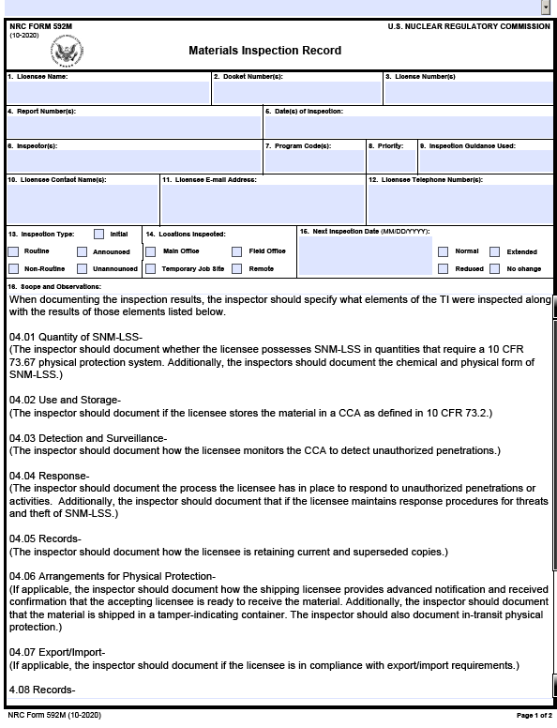

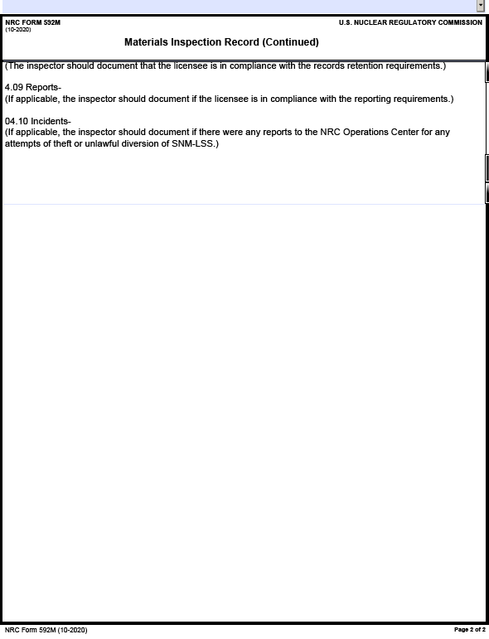

Attachment 1: Revision History for TI 2800/044
Commitment Tracking Number | Accession Number  Issue Date  Change Notice | Description of Change | Description of Training Required and Completion Date | Comment Resolution and Closed Feedback Form Accession Number  (Pre-Decisional Non-Public Information)
N/A | ML22091A036  03/06/23  CN23-005 | Initial Issuance | N/A | ML22091A052

Under AEA section 274b., the NRC can only relinquish its regulatory authority that pertains to the protection of the public health and safety from radiation hazards. The NRC cannot relinquish its regulatory authority that pertains to common defense and security matters (AEA section 274m).
Pursuant to 10 CFR 150.11, the SNM quantities not sufficient to form a critical mass are: uranium enriched in the isotope U-235 in quantities not exceeding 350 grams of contained U-235; uranium-233 in quantities not exceeding 200 grams; plutonium in quantities not exceeding 200 grams; or any combination of them in accordance with the following formula: For each kind of special nuclear material, determine the ratio between the quantity of that special nuclear material and the quantity specified above for the same kind of special nuclear material. The sum of such ratios for all kinds of special nuclear materials in combination shall not exceed unity.
The SNM-LSS quantities designated in 10 CFR 150.14 are: quantities greater than 15 grams of plutonium or uranium-233 or uranium-235 (enriched to 20 percent or more in the U - 235 isotope) or any combination greater than 15 grams when computed by the equation grams=grams uranium-235+grams plutonium+grams uranium-233.

