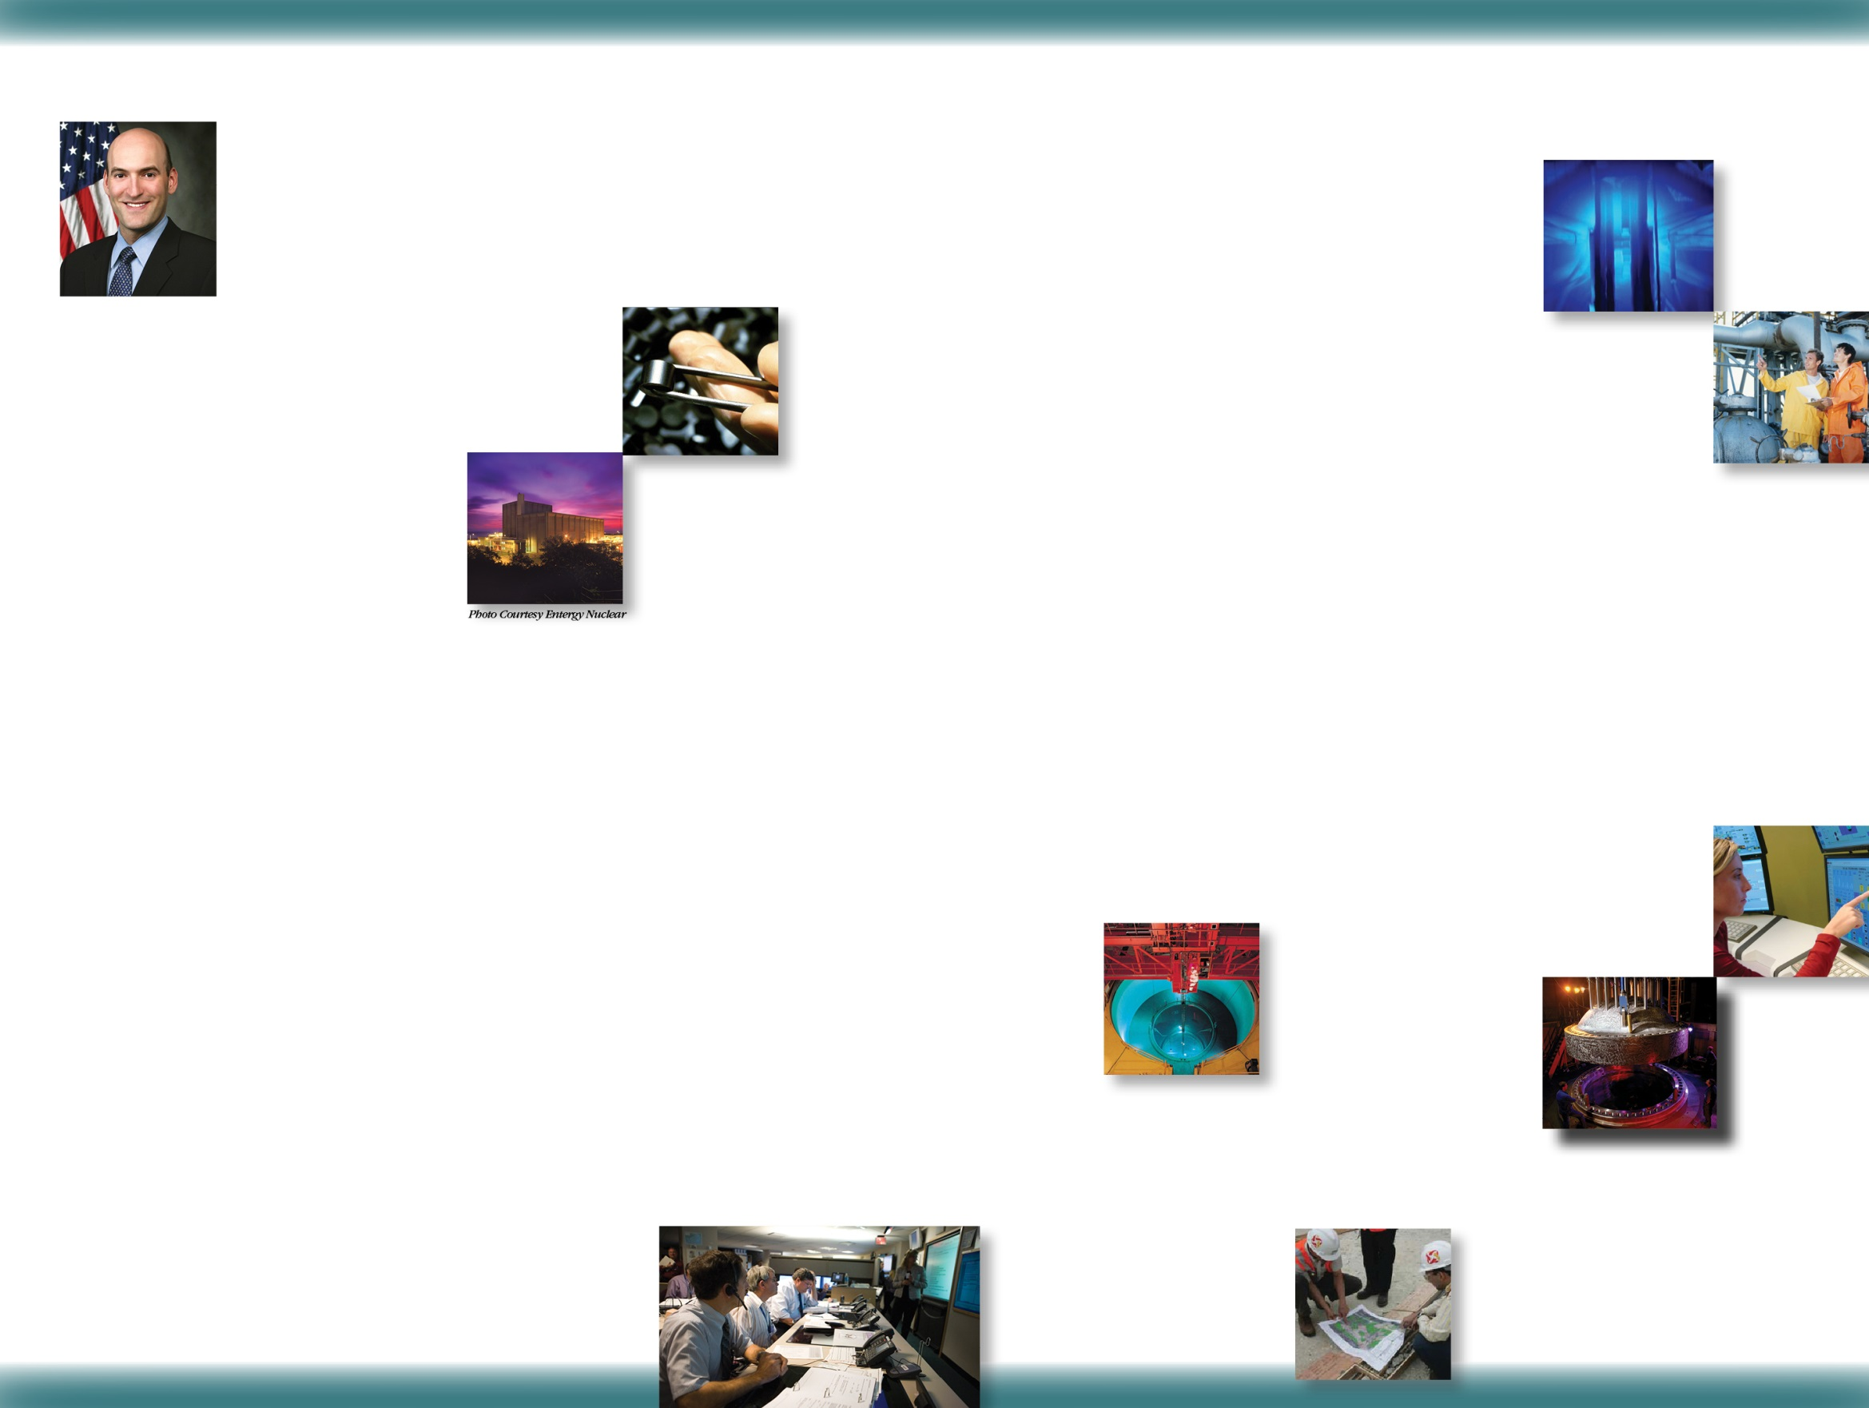

### INTRODUCTORY MESSAGE

### 

### [to be added by State]

**IMPORTANCE FOR REGULATED ENTITIES**

Industry experience has

shown the value of

establishing and main-

taining a positive safety

culture. The NRC be-

lieves that through our

continued outreach

activities this value will become apparent.

It is important to remember that individuals

and organizations performing regulated

activities bear the primary responsibility for

safety and security. The NRC can monitor

and trend the performance of individuals and organizations to determine compliance with requirements and commitments. Additionally, this information may serve as an indicator of possible problem areas in an organization’s safety culture. However, the NRC does not monitor or trend the traits in the Policy Statement. The Policy Statement is not a regulation; therefore, it is the organization’s responsibility, as part of its safety culture program, to consider how to apply this Policy Statement to its regulated activities.

**MOVING FORWARD**

As the Safety Culture Policy Statement

enters the next phase, outreach, co-

operation and interaction with and between

external stakeholders will become even

more important to the

success of the policy

statement. During this

phase, the NRC staff will

continue to engage

stakeholders in dialogue

regarding the importance of a positive safety culture in

their specific activities and will also seek out feedback on

the ability of stakeholders to use the

policy statement in those activities, and to

determine whether there are areas in the

policy statement where changes may be

appropriate.

**SAFETY CULTURE POLICY STATEMENT**

In March 2011, the U.S. Nuclear Regulatory Commission (NRC or the Commission) approved the Safety

Culture Policy Statement. The Policy Statement

was developed over a three-year period during

which the agency engaged in extensive outreach

with a broad range of stakeholders.

This Policy Statement provides the NRC’s expectation that individuals and organizations performing regulated activities establish and maintain a positive safety culture commensurate with the safety and security significance of their activities and the nature and complexity of their organizations and functions. Because safety and security are the primary pillars of the NRC’s regulatory mission, consideration of both safety and security issues, commensurate with their significance, is an underlying principle of the Safety Culture Policy Statement.

The policy statement applies to all licensees, certificate holders, permit holders, authorization holders, holders of quality assurance program approvals, vendors and suppliers of safety-related components, and applicants for a license, certificate, permit, authorization, or quality assurance program approval subject to NRC authority. In addition, the Commission encourages the Agreement States (States that assume regulatory authority over their own use of certain nuclear materials), their licensees, and other organizations interested in nuclear safety to support the development and maintenance of a positive safety culture within their regulated communities.

**BACKGROUND**

The 1986 nuclear accident at the Chernobyl nuclear power plant in the Ukraine revealed the importance of safety culture and the impact that weaknesses in safety culture can have on safety. Since then, the importance of a positive safety culture has been further demonstrated by a number of significant events in the United States and the

international community. Assessments of these

events revealed that safety culture weaknesses

were an underlying cause or increased the

severity of problems.

The NRC addressed the importance of safety culture in two previously issued policy statements. The 1989 “Policy Statement on the Conduct of Nuclear Power Plant Operations” applies to all individuals engaged in activities that affect the safety of nuclear power plants and provides the NRC’s expectations for utility management and licensed operators in the conduct of operations. The 1996 “Freedom of Employees in the Nuclear Industry To Raise Safety Concerns Without Fear of Retaliation” policy statement applies to the regulated activities of all NRC licensees and their contractors and subcontractors. It provides the expectation that licensees and other employers subject to NRC authority establish and maintain work environments in which employees feel free to raise safety concerns without fear of retaliation.

Following the September 11, 2001 terrorist

attacks, the Commission issued orders enhanc-

ing security at nuclear facilities. During the

early years of implementation of these en-

hancements, several violations of the enhanced requirements occurred because of failures to

cultivate a positive safety culture in the licensee’s security program. While discernable progress has been made by the nuclear community to strengthen nuclear safety culture since the Chernobyl accident, the NRC seeks to further

emphasize the critical

importance of safety

culture by the issuance

of this Policy

Statement.

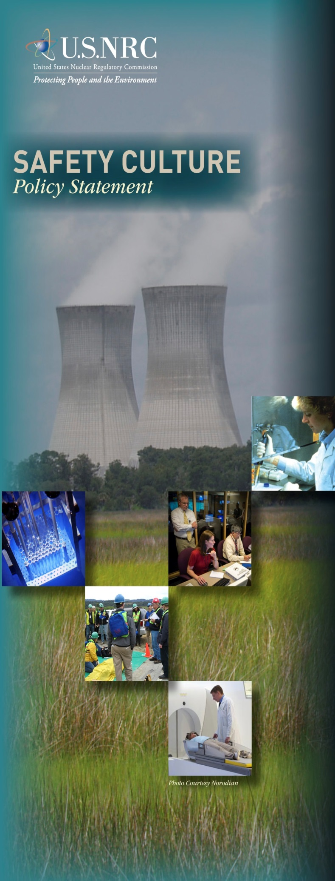

This brochure is based on U. S. Nuclear Regulatory Commission publication NUREG/BR-0500, June 2011

**TO GET MORE INFORMATION FROM THE NRC:**

www.nrc.gov

www.nrc.gov/about-nrc/ safety-culture.html

**DEFINITION OF NUCLEAR SAFETY CULTURE**

Nuclear safety culture is the core values and behaviors resulting from a collective commitment by leaders and individuals to emphasize safety over competing goals to ensure protection of people and the environment.

**TRAITS OF A POSITIVE NUCLEAR SAFETY CULTURE**

Experience has shown that certain personal and organizational traits are present in a positive safety culture. The following are traits of a positive safety culture:

**• Leadership Safety Values and Actions**—Leaders demonstrate a commitment to safety in their decisions and behaviors.

**• Problem Identification and Resolution**—Issues potentially impacting safety are promptly identified, fully evaluated, and promptly addressed and corrected commensurate with their significance.

**• Personal Accountability**—All individuals take personal responsibility for safety.

**• Work Processes**—The process of planning and controlling work activities is implemented so that safety is maintained.

**• Continuous Learning**—Opportunities to learn about ways to ensure safety are sought out and implemented.

**• Environment for Raising Concerns**—A safety-conscious work environment is maintained where personnel feel free to raise safety concerns without fear of retaliation, intimidation, harassment, or discrimination.

**• Effective Safety Communication**—Communications maintain a focus on safety.

**• Respectful Work Environment**—Trust and respect permeate the organization.

**• Questioning Attitude**—Individuals avoid complacency and continuously challenge existing conditions and activities in order to identify discrepancies that might result in error or inappropriate action.

There may be additional traits not included here that are also important in a positive safety culture. These traits were not developed for inspection purposes.

### MISSION

### 

### [to be added by State]

### [State agency name and address]